Section 1. Maths and IT Technologies

Robust Stability of Differential-Algebraic Equations
A.D. Kononov
Matrosov Institute for System Dynamics and Control Theory of Siberian branch of Russian academy of sciences (ISDCT SB RAS)
e-mail: my_official@rambler.ru

Consideration was given to the linear stationary systems of differential-algebraic equations with an arbitrarily high implication index
$\left(A+∆_{2}\right)x^{'}\left(t\right)+\left(B+∆_{1}\right)x\left(t\right)=0, t∈T=\left[0,+∞\right)$ (1)
where $A$ and $B$ are given, $∆_{1}$ and $∆_{2}$ are unknown. It is assumed that $\det{A}=0$ and $λA+B≠0$.
Differential-algebraic equations (DAE) simulate processes in many areas of science: mechanics, chemistry, heat engineering, theory of electrical circuits, control theory and etc. The implication index reflecting complexity of the system internal structure is the most important characteristic of differential-algebraic equation.
There are many known results related to stability. In practice, however, we always have an error in the input data. These equations with uncertain data are considered in control theory, namely, in the theory of robust stability, but research is at an early stage today. The greatest difficulty is connected with the fact, that arbitrary perturbation of input data may change the structure or increase the order of equation. There are some results of robust stability and some stability radius evaluations, which are produced by converting to Kronecker-Weierstrass canonical form. As for the nonstationary DAE, there exist results for the system of index one with periodic coefficients using the tractability index approach relying on construction of projectors on the kernel. Also, there are some results for time-varying case.
We investigate the asymptotic stability of the system (1) under the conditions of asymptotic stability of the system
$Ax^{'}\left(t\right)+Bx\left(t\right)=0, t∈T=\left[0,+∞\right)$ (2)
The stability radius is a distance from a stable system to the nearest instable one.
The analysis is performed under the assumption that ensure the existence of the operator
$R=R_{0}+R_{1}\frac{d}{dt}+⋯+R_{r}{\left(\frac{d}{dt}\right)}^{r},$ (3)
that converts the system (2) to
$\left(\begin{matrix}O & O \\ E_{n-d} & O\end{matrix}\right)Qx^{'}\left(t\right)+\left(\begin{matrix}J_{1} & E_{d} \\ J_{2} & O\end{matrix}\right)Qx\left(t\right)=O.$ (4)
where $r$ is an implication index, $E_{d}$ is an identity matrix, $Q$ is an permutation matrix.
The equation (4) is equivalent to the DAE (2), but its differential and algebraic parts are separated. Additionally, the operator $R$ has an inverse operator like
$$L=L_{0}+L_{1}\frac{d}{dt}.$$
Now we can set restrictions to the elements of $∆_{1}$ and $∆_{2}$ matrices. Furthermore, we can evaluate stability radius using the results known.
The perturbations $∆_{1}$ and $∆_{2}$ are not said to affect the internal structure of DAE (2) if there exists an invertible operator
$$\tilde{R}=\sum_{j=0}^{\tilde{r}}{{\tilde{R}}_{j}{\left(\frac{d}{dt}\right)}^{j}}$$
such that its action on system (1) convert it in
$$\left(\begin{matrix}O & O \\ E_{n-d} & O\end{matrix}\right)\tilde{Q}x^{'}\left(t\right)+\left(\begin{matrix}G_{1} & E_{d} \\ G_{2} & O\end{matrix}\right)\tilde{Q}x\left(t\right)=O$$
where $G_{1}$ and $G_{2}$ are some matrices of corresponding sizes.
Under the assumption of structural persistence, the sufficient conditions for robust stability were obtained, and the value of stability radius is given. The construction of the structural form is constructive and does not use a variable replacement.

The space-time distribution of proton flares on the sun

E. S. Isaeva
Institute of Solar-Terrestrial physics of the Siberian branch of the Russian academy of sciences (ISTP SB RAS)
e-mail: ele3471@yandex.ru

To revealing regularities in the space-time distribution of proton solar flares on the surface of the Sun is important for prognosing of their. It is necessary to test the hypothesis that the most powerful fluxes of protons reaching the Earth are formed in the flares that differ in the quite definite topology of the nearby large-scale magnetic field. We show the interrelation of these flares with complexes of activity on the Sun and coronal holes. In particular, the aim was to compare the locations of the occurrence of the most flares. These flares are distinguished by the most powerful proton fluxes, with the location of the magnetic polarity separation line calculated at the so-called source surface (at a height of 2.5 solar radius).
We are planning:
• to select flares that gave high fluxes of protons in the Earth's orbit, and to calculate their longitudes in the Carrington coordinate system on the surface on the Sun;
• to determine the distances from these flares to the line of separation of polarities on the surface of the source;
• to identify the reference to the complexes of activity and compare their numbers;
• to determine the presence of coronal holes near the source of proton flares;
• to analyze the data;
• to draw a conclusion about the degree of legitimacy of the a priori hypothesis;
• to construct an algorithm for the prediction of the location of flares, depending on the shape of the polarity separation line and the 11-year cycle phase;
• to try to build an algorithm for forecasting proton flares, depending on their preference to the complexes of activity and the proximity of coronal holes.
As an object of the study, the regularities of the emergence of a selected population of solar flares were chosen. This work was carried out in the framework of planned studies conducted by the Astronomical Observatory of ISU at the present time.
The relevance of this work is that flares that provide high values of the proton flux in the Earth's orbit are geoeffective, that is, they affect the parameters of the human environment and partly the technosphere. If we learn to predict such outbreaks, it will facilitate preparation for such phenomena and prevention of their consequences.
Solar flares are usually called proton, during which streams of accelerated hydrogen nuclei with energies from one to hundreds of millions of electron volts (so-called solar cosmic rays) are recorded in the vicinity of the Earth. Naturally, such a definition of proton flares does not include all processes accompanied by acceleration of particles on the Sun, because in some cases the proton flux may not reach near-Earth space. After such outbreaks, both complete radio wave absorption in the polar regions, a strong magnetic storm, and the Forbush effect (a decrease in the level of cosmic rays of non-solar origin), which occurs due to the screening of the Earth by the plasma stream coming from the Sun, were observed on Earth.
For the study, I took the data on proton flares in 21, 22, 23 and 24 cycles of solar activity. At the moment, I have already calculated their Carrington longitudes, identified the corresponding numbers of the Carrington revolutions for these flares, and plotted all flashes on the source surface maps. The distances, designed to the level of the solar photosphere, from each flash to the line of separation of magnetic polarities on the surface of the source were also determined. The following analysis was made: plots of the remoteness of the flares versus the polarization line on the photosphere were plotted, a dispersion of these values ​​was found. We plotted the remoteness of the flares versus the polarity separation line from the phase of the cycle and the distribution of the values ​​obtained. Moreover, we determined the latitude of the flares versus time during the development of cycles. In addition, the distributions of the number of flares from their X-ray classes and the dependence of the proton flux on the X-ray burst class were constructed. Also, all flares for the reference to the activity complexes were checked.

Improving the reliability and performance of a data storage system with RAID technology

R.O. Kostromin, Y.A. Dyadkin
Matrosov Institute for System Dynamics and Control Theory of Siberian branch of Russian academy of sciences (ISDCT SB RAS)
e-mail: romang70055@gmail.com

Currently in large-scale scientific and applied research in various fields of mathematical modeling (for example, in the study of queuing systems) there are two classes of problems which are given special attehntion: computing tasks and data processing tasks. The tasks of the latter class are related to the generation and processing of large data streams. The time and quality of the results of solving such problems are directly related to the efficiency of the data storage system, including the speed of their reading and writing, ensuring the integrity of the data. Thus, the task of improving the reliability and performance of the data storage system is still topical [1].
One of the solutions to increase the speed of work with disk drives is the replacement of conventional hard disk drives (HDD) with solid-state disks (SSDs). However, this method is not always justified, because SSD drives are characterized by a high cost and a lower operating resource, which is a significant disadvantage.
Another, a well-proven method is using a RAID technology, which consists in using a redundant array of independent disks. RAID technology allows creating high-speed and reliable disk arrays with a large amount of memory by combining relatively inexpensive HDD drives. A RAID array can be created both at the software level and at the hardware level using special controllers. In case of software implementation of a RAID array, a significant load is placed on the processor of the device. In this regard, for the maintenance of the RAID array, a dedicated device is customarily used in order not to occupy the resources of a personal computer or a computing server integrated into a heterogeneous distributed computing environment [2].
The need for a fast and reliable access to the storage system under local conditions often occurs in performing calculations related to processing large data in the office or laboratory, where there is no access to the global data storage.
The work examines aspects of implementing a RAID 0 array for a local storage system based on ARM processors. The experiments were performed with the AC68U router with an array of two HDDs of 4 TB each, connected via a USB 3.0 bus. The results of testing the read and write speed for the created array over a local network with a bandwidth of 1 Gb/s showed that the write speed averaged 44 MB/s, and readings were 94 MB/s, while without RAID, the speed was 55 MB/s and 65 MB/s, respectively. The drop in the write speed is because parallel recording is performed on both disks in the array during this operation, therefore, the bandwidth of the USB 3.0 bus is distributed between the two disks. When reading, the data are read simultaneously from two disks, which gives a higher speed. Given the increased reliability of storing experimental data and the increased read speed, we can conclude that the considered implementation of a RAID 0 array is suitable for conducting scientific experiments that require the storage of large data under local conditions, even with a reduced write speed.
The research was supported by Russian Foundation of Basic Research, projects no. 15-29-07955-ofi m and no. 16-07-00931-a, and supported in part by the Council for Grants of the President of Russian Federation for state support of the leading scientific schools, project NSh-8081.2016.9.
References
- Fitch D., Xu H. A RAID-based secure and fault-tolerant model for Cloud information storage // International Journal of Software Engineering and Knowledge Engineering, 2013, pp.100-127.
- Patterson D. A., Chen P., GibsonG., Katz R.H. Introduction to redundant arrays of inexpensive disks (RAID), Proc. of the COMPCPN Spring’89, Thirty-Fourth IEEE Computer Society International Conference: Intellectual Leverage, Digest of Papers, 1989, pp. 112-117.

SAT-based Cryptanalysis

I.A. Gribanova
Matrosov Institute for System Dynamics and Control Theory of Siberian branch of Russian academy of sciences (ISDCT SB RAS)
e-mail: dukkham@yandex.ru

It is generally agreed today that our life greatly depends on computers, networks and information technologies. This leads to the problem of data protection using different ciphers or cryptosystems. Cryptanalysis refers to the study of these systems to find weaknesses in them. Cryptanalysis problems can be considered in terms of Boolean Satisfiability Problem (SAT), which is the following: to decide whether an arbitrary Boolean formula is satisfiable or not. This approach forms theoretical foundation of SAT-based cryptanalysis. Since SAT is NP-complete problem, there is no universal polynomial algorithm that could solve SAT-problems fast (in polynomial time). However, some heuristic algorithms show good results in practice [1].
Consider total computable discrete function of the kind:
$f:{\{0,1\}}^{*}→{\{0,1\}}^{*}$ (1)
Let us denote the set of all binary words of an arbitrary finite length by ${\{0,1\}}^{*}$. Hereinafter it is assumed that $f$ is specified by some program (algorithm) $A_{f}$ that has finite runtime on each word from ${\{0,1\}}^{*}$and forms a family of functions of the kind $f_{n}:{\{0,1\}}^{n}→{\{0,1\}}^{n}, n∈N$. The problem of inversion of an arbitrary function $f_{n}$ is formulated as follows: based on the known ${y ∈Range f}_{n}$ and the known algorithm $A_{f}$, find such $x∈{\{0,1\}}^{n}$ that $f_{n}\left(x\right)=y$.
The functions of the kind (1) used in cryptography are usually constructed in such a way that their inversion problems are computationally hard. Meanwhile the computation of these functions themselves should be fast, otherwise the ciphering speed of the cryptosystem based on such a function will be low. The ability to compute f effectively makes it possible to apply the approach based on the propositional encoding of $A_{f}$ program to its inversion. The idea of propositional encoding was implemented in the TRANSALG system [2]. This system automatically reduces the inversion problem of an arbitrary function to a SAT-problem in the Conjunctive Normal Form (CNF).
Today many real word cryptanalysis problems such as cryptanalysis of keystream generators and hash functions can be solved as a SAT-problem. A keystream is a pseudorandom sequence of an arbitrary length (constructed using a secret key $x$) used to cipher some plaintext via bit-wise XOR operations. Knowing some fragment of plaintext, let us know the corresponding fragment of keystream, i.e. some word $y$ for which the problem of finding such $x$ that $f_{n}\left(x\right)=y$ can be considered. Regarding cryptographic keystream generators this corresponds to the so called known plaintext attack.
Hash functions are total functions of the kind $f:{\{0,1\}}^{*}→{\{0,1\}}^{c}$; $c$ is a constant value. If $n$ is a length of an input message and $n>c$, then there exist two different messages $x_{1},x_{2}$ that $f\left(x_{1}\right)=f\left(x_{2}\right)$. Such a pair ($x_{1},x_{2})$ is called a collision of a hash function $f$.
The arguments for the effectiveness of SAT-based cryptanalysis in application to several ciphering systems such as A5/1 keystream generator and MD4 and MD5 cryptographic hash functions can be found in [3] (the propositional encodings were produced by the TRANSALG system). From these facts we can conclude that SAT-based cryptanalysis is of great practical importance for modern cryptography.

References:
- Biryukov, A., Shamir, A., Wagner, D.: Real time cryptanalysis of A5/1 on a PC. In: Schneier, B. (ed.) Fast Software Encryption, Proceedings. Lecture Notes in Computer Science, vol. 1978, pp. 1–18. Springer (2000)
- Otpuschennikov, I., Semenov, A., Gribanova, I., Zaikin, O., Kochemazov, S.: Encoding cryptographic functions to SAT using TRANSALG system. In ECAI 2016 - 22nd European Conference on Artificial Intelligence. Frontiers in Artificial Intelligence and Applications, vol. 285. IOS Press (2016) 1594–1595
- Bogachkova (Gribanova), I., Zaikin, O., Kochemazov, S., Otpuschennikov, I., Semenov, A., Khamisov, O.: Problems of search for collisions of cryptographic hash functions of the MD family as variants of Boolean satisfiability problem (in Russian). Numerical Methods and programming 16(1) (2015) 61–77

Underwater environment generation as a part of simulation modeling system of underwater vehicles

K.V. Bedenko
Matrosov Institute for System Dynamics and Control Theory of Siberian branch of Russian academy of sciences (ISDCT SB RAS)
e-mail: bedenko@icc.ru

3D-modelling of underwater environment is the first stage in the process of functioning of the simulation modeling system of underwater vehicles.
Based on the terrain made there can be several possibilities:
- to fulfill the algorithms of intelligent behaviors of underwater vehicles;
- to develop program-modeled sensors, the systems of interactions between the robots and the underwater environment;
- to implement fault and failure control system, etc.
To achieve the aim of well-modeled terrain it is necessary to choose a program complex or development framework. Comparing Unity3D with Unreal Engine (two of the most popular and effective frameworks) showed all the benefits of Unity3D and the drawbacks of Unreal Engine related to the terrain generation task to be solved.
The task to be solved is to model the natural relief of a seabottom. There are five main types of the relief in the ocean: a shelf, an abyssal plain, a mid-ocean ridge, a seamount and an oceanic trench. To create such types of terrain (or their combination) one should choose the method of procedure terrain generation. There are two basic ways to achieve this goal.
The first is to use fractal terrains by the example of Diamond-Square algorithm. The main drawback of this algorithm is the constraint of generated area. It is impossible to create “infinite” terrains since each terrain is limited by initial parameters of generation (width and length of an area). And that’s why it is important to save all the results of implementation of this algorithm.
Alternatively, there is the second group of methods of procedure terrain generation using pseudonoise. One of the most well-known algorithms in this group is named as Perlin Noise – a type of gradient noise developed by Ken Perlin in 1983. The structure of this algorithm allows the program to generate “infinite” terrains without saving generated terrain but only with saving parameters of scale, shift point of the texture, or some more parameters developed by programmers while trying to create a certain terrain height map. Thus, it was obvious to choose Perlin Noise to implement simulation modeling system of underwater vehicles.
Let’s consider height h presentation in the form of h = k * f(x, z) + b, where
k – linear coefficient,
b – vertical skew coefficient,
f(x, z) – function realization of Perlin Noise.
Three ways to combine simple terrains were developed: terrains superposition, heights and areas coupling. Let’s consider the example of the terrains with two layers of Perlin Noise coupled by heights.
Let h1 = 0.4, scale1 = 4, scale2 = 18, Hmax = 200 meters.
1. To create L1 and L2 terrains with scale1 and scale2 accordingly.
2. To sever heights [h1, 1] from L1 and normalize height map. Height map Temp1 is obtained.
3. To sever from L2 the areas where heights with identical coordinates (x, z) are less than those from L1. Height map Temp2 is obtained. To normalize it.
4. To multiply related heights from Temp1 and Temp2 (it is necessary to put on L1 height map Temp2 starting with height h1 but without visible seams).
5. To put height map obtained on forth step on L1 limited with [0, h1]. Normalize the result.
Fig.1. The terrains obtained using heights and areas couplings.
The task of seabottom terrain generation is complex and can be accomplished using many ways. The way presented in the paper allows the computer to use sparingly computational resources and makes development easier. Perlin Noise in Unity3D is good alternative to generating procedure terrains and it gives the developers a wide range of next changes and modifications.

Developing optical and electronic devices for high resolution observations
I. V. Russkikh, D. Y. Kolobov
Institute of Solar-Terrestrial physics of the Siberian branch of the Russian academy of sciences (ISTP SB RAS)
e-mail: vanekrus@mail.iszf.irk.ru

It is known that a star is heterogeneous and has a determined structure. The core is the hottest part of the Sun. Its temperature is more than 14 million kelvins. The temperature decreases to 2 million kelvins at the end of the radiative zone. At the photosphere level the temperature is only about 4-6 thousand kelvins. However, above it the temperature grows up to 20 thousand kelvins in the chromosphere and to 1 million kelvins in the corona. At the special regions of corona it can grow up to 20 millon kelvins.
One of the most topical problem in Solar physics is the energy transition to the outer layers of the Solar atmosphere. Mainly, two ways of it are considered. One of them is Solar magnetic field line reconnection that results in excessive energy releasing. The other way is in special role of the waves in Solar plasma. During the latest 30-40 years phenomenology of the spatial and altitudinal stratification of the wave-oscillatory processes was studied well. Also, Solar plasma MHD-waves propagating models were developed. Today the observational data of high temporal and spatial resolution make it possible to analyze the parameters of the separate wave propagating along single magnetic field line. Scientists succeeded mostly in coronal seismology where the waves themselves are the means of magnetic field measurment (Uchida, PASJ, V.22, P.341, 1970; Roberts et al., ApJ, V.279, P.857, 1984; Nakariakov \& Ofman, A\&A, V.372, P.53, 2001). The technique measures loop lateral oscillations period (kink-mode), which are observed mainly in the UV range. There is also a possibility to extract plasma density altitudinal distribution (Andries et al., ApJ, V.624, L57, 2005) and some other parameters. Due to this, Solar atmosphere seismological diagnostics is of great interest (Stepanov et al., “Coronal seismology”, УФН, Т.182, С.999, 2012).
Historically, corona and solar atmosphere umbral dots seismology are divided into two research trends. Probably, during previous decades this division was determined by the lack of observation possibilities. After space orbital observatories launch, SDO in particular (Scherrer et al., Solar Physics, V.275, P.207, 2012), the multiwave analysis from corona to photosphere became possible. It opens new possibilities and new tasks in Solar seismology. On this way one may face a well-known problem of the joining the representations of photosphere-chromosphere-corona layers. Nowadays, most informative chromosphere and photosphere observations are made using previous generation ground-based telescopes. The development of the equipment for multiwave spectrum and filter observations with adaptive optics is based on these telescopes.
Experimental research of thin structure of the solar atmosphere implies solving a number of observational problems and developing appropriate techniques and equipment. Two- and threecascades ultranarrowband filter systems with bandwidth from 1 to 0.001 nm are developed to use for three dimensional spectroscopy, for spectropolarimetry with measuring all of the Stokes parameters of the emission being analyzed to compose the maps of the longitudinal and full magnetic field vector of astronomical objects. The unique filter systems CRISP (arXiv:1109.1301v2), IBIS (arXiv:1001:0561v1), IRIM, DOT are known and systems for DKIST(Allen Gary et al, Proc. SPIE Vol. 4853, 2003), EST (Puschmann et al., ASP Conf. Ser., 2012, arXiv:1111.5509v2), NST, NLST (Ravindra and Banyal, ASI Conf. Ser., Vol. 2, 2011) are intensively being developed. The choice of the filter system optimal construction for multiwave thin structure studying is a topical problem, which solution is determined by the successful experimental samples. At present, Solar atmosphere lower layers (photosphere, temperature minimum, chromosphere) complex observation results are rare and available only for some scientists. Solar tomography in such spectral regions as “G-band” λ=4305Å, blue and red continuum, Нα, Ва II (4554Å), Ca II K, TiO (λ=7058Å) with high spatial and temporal resolutions will significantly enlarge our knowledge in physics of the processes which as expected determine energy transition to outer layers and also determine the evolution of different Solar atmosphere magnetic structures.
The study of the energy transition to outer layers of the Sun requires very high spatial resolution – of the order of 0”.1 or better. It allows us to observe such small structures as umbral dots which typically exhibit diameters between 0”.2 – 0”.8 and intensities 1.3 – 1.5 times brighter than the background umbral value (Jess et al., ApJ, V.757, L160, 2012). On an average, the resolution of the Solar telescopes without adaptive optics is about 1-2” because of the wavefront distortion induced by the atmosphere airflows (Geary, “Adaptive optics engineering handbook”, p. 123, 2000). Adaptive optics are to compensate these distortions and allow one to obtain spatial resolution of the order of 0”.1.
Finally, these researches determine the possibilities to create future large-aperture telescopes, and consequently to solve these problems in Solar Physics.

Modeling interferogram images for the output data simulation of Fabry-Perot interferometer

M.F. Artamonov, R.V. Vasilyev
Institute of Solar-Terrestrial physics of the Siberian branch of the Russian academy of sciences (ISTP SB RAS)
e-mail: ursus_arctos@inbox.ru

Introduction
Determining condition parameters and their dynamics of the neutral atmospheric component has a great importance for the studies in the field of solar-terrestrial physics and developing atmospheric models. The study is closely related to the upper atmosphere of the Earth. In order to characterize this region of the atmosphere, we are to obtain such important parameters as the values of temperature and a wind velocity vector. As is known, the atmosphere consists of the gas mixture and each gas has an important property to glow under the influence of sun and cosmic rays radiation. Such glow is caused by an electromagnetic emission of atoms and molecules, and the spectrum lies near some wavelength as the main characterizing parameter. In turn, the emission wavelength for the each gas is affected by the thermal and collective molecule motions. Similar dependence is called the Doppler effect. On the one hand, the thermal motions lead to the broadening of emission spectrum, but collective motions – to the occurrence of the spectrum shift. On the other hand, the thermal motion defines a temperature, and the collective motion defines a wind velocity. This way, the measuring of the gas emission spectrum broadening and shifting is necessary to determine temperature and wind velocity respectively.
The region of upper atmosphere referring to 250 km altitudes is of interest for our study. There is maximum atomic oxygen concentration at this height with strong airglow emission line having the wavelength $λ=630nm$. So, the method to make measurement of broadening and shifting spectrum for the red line emission of atmospheric oxygen is necessary. The Fabry-Perot Interferometer (FPI) is the suitable instrument aimed at solving a similar task. One FPI is available in geophysical observatory of the Institute of Solar-Terrestrial Physics. This device produces images of interferograms occurring while observing night sky airglow in the red line spectrum range. Later, they are processed using special FPI software (FPIS) to obtain temperatures and wind velocities [1].
In this study, the simulation of such images was carried out. Firstly, it allowed us to verify the accuracy of the temperature and wind reconstructions by FPIS. Secondly, we could use them to model various physical phenomena in the upper atmosphere and to study their influence on the parameters investigated.
Simulated data analysis and conclusions
In the process of simulation, various images were calculated with monotonic increasing temperatures, wind velocities, signal and background intensities. The studies show, firstly, that the parameters were recovered with adequate accuracy, and secondly, there was no significant dependency between parameters, for example with increasing temperature the wind velocity and the intensity of signal and background were nearly constant. Figure 1 shows this statement.
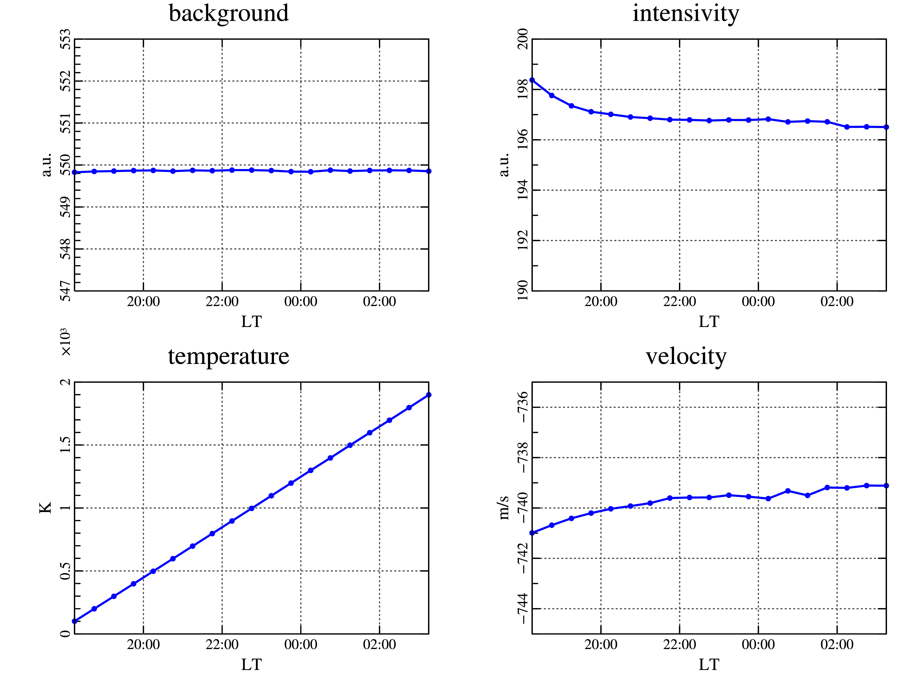
Figure.1 Recovered parameters of the interferogram with linear increasing temperature at fixed wind velocities, signal and background intensities.
As is known [2], the atmosphere contains hydroxyl groups having emission lines located near the wavelength of the atomic oxygen with $λ=630nm$ being of interest for us. Such neighborhood causes the contamination of a useful signal. The closest hydroxyl lines are P₁(2), P₂(3), P₁(3), with wavelengths 628.75 nm, 629.79 nm and 630.70 nm respectively. It was found [1], the only line P₁(3) has interference orders superimposing on the red line oxygen interference orders in observing by FPI. This fact can lead to misinterpretation of the results. In connection with above phenomenon, the simulation of the mixing oxygen and hydroxyl lines was made. It was discovered (see fig. 2), that the stronger intensity of the hydroxyl emission, the lower the measured temperature of the observed atmosphere area. However, if oxygen and hydroxyl emission intensities are equal, then the temperature is becoming higher than for each of the line taken separately. Such a local splash is not observed during real image processing and it can be interpreted as a negligible influence of the hydroxyl emission contamination on oxygen emission line.
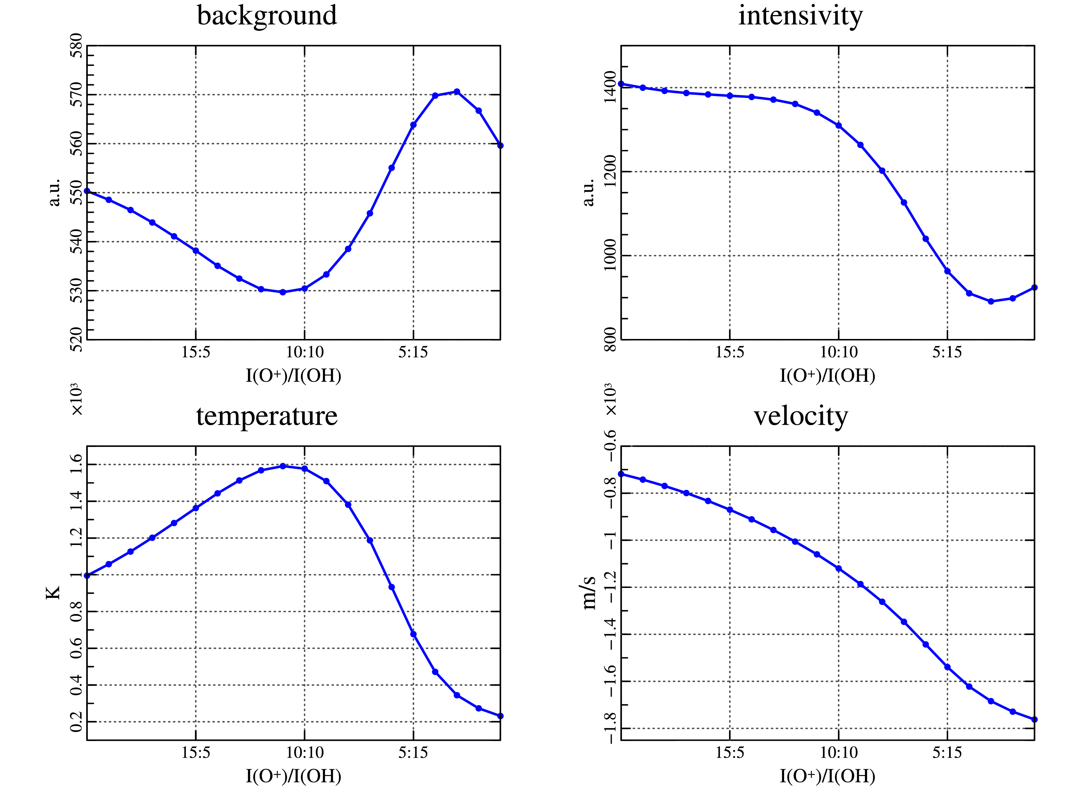
Figure.2 Recovered parameters of the interferogram with decreasing intensity of the oxygen emission line and simultaneous increasing intensity of the hydroxyl emission line.

References:
- Vasilyev R.V., Artamonov M.F., Beletskiy A.B., Jerebtsov G.A., Medvedeva I.V., Mihalev A.V., Syrenova T.E. Registration of the upper atmosphere parameters in East Syberia region using Fabry-Perot Interferometer KEO Scientific "Arinae". Jurnal "Solnechno-zemnaya fizika" [Journal "Solar-Terrestrial Physics"], in print, 2017
- Hernandez G., «Contamination of the O I (P2-D2) Emission Line by the (9-3) Band of OH XII in High-Resolution Measurements of the Night Sky», Journal Of Geophysical Research, Vol. 79, No. 7, March 1, 1974.

Comparison of ionospheric models of the total electron content for the Glonass system

D.A. Zatolokin
Institute of Solar-Terrestrial Physics of the Siberian branch of the Russian academy of sciences (ISTP SB RAS)
e-mail: clausxxx@rambler.ru

Introduction
The greatest contribution to the overall positioning error of objects in global navigation satellite systems (GNSS) gives an additional delay in the propagation of radio navigation signals on the way SATELLITE - RECEIVER [1]. In turn, this contribution consists of the parts of approximately the same order of magnitude: an additional delay in the neutral gas of the lower atmosphere (troposphere) and the ionized shell of the upper atmosphere (ionosphere). The correction of additional delay in the propagation medium in the single-frequency radionavigation equipment is carried out using environment models. If for the troposphere such a correction works quite satisfactorily even for very simple models, then with the ionospheric correction the situation looks more complicated. The standard model recommended to be used in the GPS system is the so-called Klobuchar model [2] included in the GPS Interface Control Document (GPS) [3]. Being developed in the 80s of the last century and, it was widely distributed, but now it is obsolete. In the first versions of the GLONASS Interface Control Document, there were no recommendations for correcting the additional ionospheric lag. However, in the latest version of the ICD [4], such a recommendation already exists. Namely, the document gives the details of the algorithm for carrying out the corresponding calculations.
At the Irkutsk branch of the Moscow State Technical University and the Irkutsk State University, a model of the total electron content (TEC) of the ionosphere was jointly developed, called GEMTEC [5], which is an alternative to the models, mentioned above. In this regard, it is of primary interest to obtain quantitative estimates of the accuracy of reproducing the values ​​of TEC using different models, which is the goal of this work.
Results of comparative testing of models
In the example of calculations based on the model presented in the GLONASS ICD, the conditions corresponding to the month of March with an average monthly value of the index F10.7 of 70 were chosen, equal to 70. Similar conditions occurred in March 2009, therefore, for calculation purposes, two days were arbitrarily chosen - 4 and 21 March. Also, three points of the mid-latitude region with geographic coordinates were chosen for calculations: point A - 50 ° C and 0 ° EL, point B - 55 ° NL and 60 ° EL, point C - 45 ° NL and 120 ° EL. The conditions of the mid latitudes of the northern hemisphere are of the greatest interest for GNSS users in the Russian Federation.
For the indicated dates and geographical positions from the GIM maps from the CODE center, the daily moves of the vertical TEC were taken - 12 time points from 0 to 22 hours of world time UTC inclusive with a time step of 2 hours. The actual values ​​of the solar activity index and the coefficients of the Klobuchar model were introduced into the calculation programs, and for these dates, the daily TEC progress was calculated for comparison with the moves from the GIM maps.
A graphic illustration of the calculations for points A, B, C is shown in Fig. 1, 2, 3, respectively. The left parts of the drawings refer to March 4, 2009, the right-hand sides - by March 21. The global time UTC in hours is plotted along the horizontal axis, and the vertical TECU values ​​in vertical units. The solid broken line illustrates the course of the TEC using GIM maps, the dot polyline - the TEC stroke according to the GEMTEC model, the broken polyline - the TEC motion according to the GLONASS model and the dash-dot broken line - the TEC stroke according to the Klobuchar model.

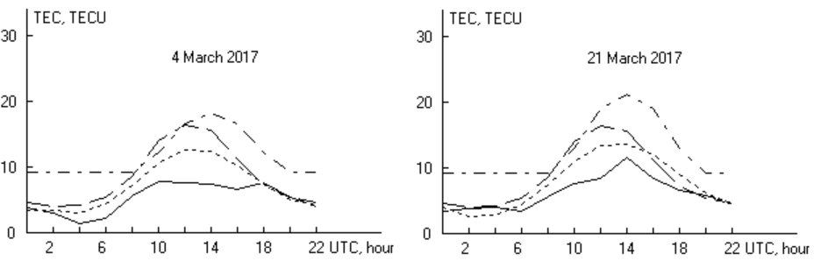
Fig. 1. The daily course of the vertical TEC for point A.

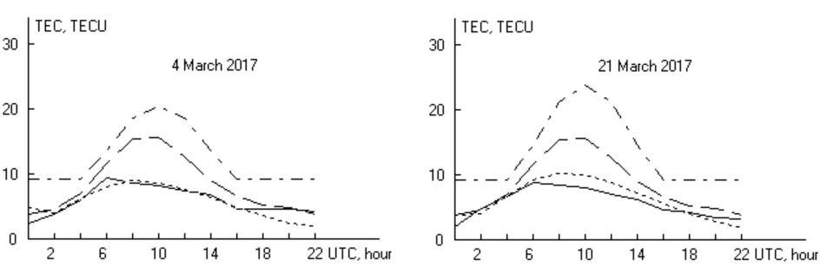
Fig. 2. Daily course of vertical TEC for point B.

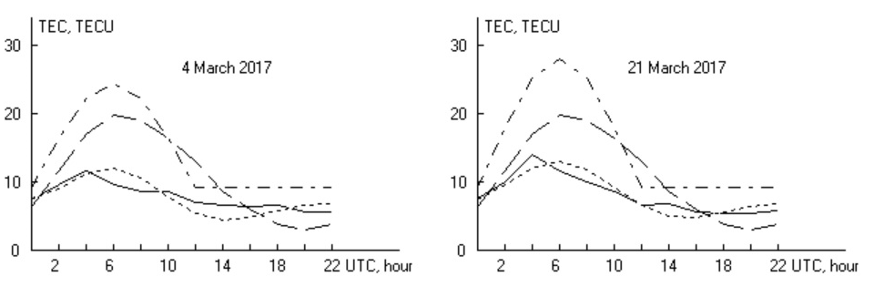
Fig. 3. Daily course of vertical TEC for point C.

From the data presented it is quite obvious that:
1. The Klobuchar model reproduces the actual course of the TEC much worse than the other two models.
2. The GEMTEC model shows a noticeably better result than the GLONASS model.
These conclusions are valid for each of the six presented figures.
Conclusion
The testing carried out showed that for the GLONASS system (as, indeed, GPS), it is possible to use modern models of the total electron content of the ionosphere, providing much higher accuracy of the current value reproduction of the TEC, and, consequently, a higher positioning accuracy than using the Klobuchar model. At the same time, the GEMTEC model demonstrates much greater accuracy than the model recommended in the ICON GLONASS.
The advantage of the GEMTEC model in front of the GLONASS model is in its speed. A single calculation of the TEC in GEMTEC on a medium-sized personal computer takes about 3 μs, while for the GLONASS model this time is about 2 ms (this is due to the need to access a large number of mathematical functions in the program). In addition, GEMTEC requires only one external parameter - the solar activity index, and three external parameters must be entered for the GLONASS operation.
It should also be noted that for the GEMTEC model there is an experience of successful implementation of the domestic single-frequency navigation receiver MNP-M7 produced by the Izhevsk radio plant as an experimental development [13]. The GEMTEC model functioned normally and showed a noticeable increase in positioning accuracy in comparison with the standard version using the Klobuchar model.

Correlation of north-south asymmetry of spot-formation with the amplitude of 11-year cycles of solar activity
S.V.Latyshev
Institute of Solar-Terrestrial physics of the Siberian branch of the Russian academy of sciences (ISTP SB RAS)
e-mail: srg87@bk.ru

According to the data on sunspots, the correlation of the north-south asymmetry of spot formation with the amplitude of 11-year cycles is established. It is shown that the higher the absolute value of the north-south asymmetry, the smaller the amplitude of the solar cycle.

The sun is a source of colossal energy, and magnetic fields are able to accumulate and release this energy. All this has a direct impact on the earth and near-earth space, starting from geomagnetic activity on earth and ending with the climate and even the social sphere of our life. Since the sun is the largest and the nearest to the Earth source of energy, then according to the law of conservation of energy, variations of this source have a great influence on us. One of the main parameters characterizing the energy variability of the sun is Solar activity. Solar activity is a complex of phenomena and processes associated with the formation and decay in the solar atmosphere of strong magnetic fields. Such an activity being considered only in a rough approximation is equally manifested in the northern and southern hemispheres of the Sun. A detailed study of the various spot-formation indices shows that there is a rather significant north-south asymmetry, i.e. that is"asynchrony" of the work of the northern and southern hemispheres of the sun is observed.
North-south asymmetry is also one of the characteristics of global minima of solar activity. In the era of the “Maunder minimum”, the north-south asymmetry reached relatively large values ​​during several solar cycles, and the spots were observed only in the southern hemisphere. Studies of asymmetry in the restored series of SA for 2000 years have also shown that the most significant asymmetry extremes are observed during the periods of global minima.
We calculated the correlation between the amplitudes of the 11-year cycles, expressed by the total area of ​​sunspots, and the local minimums of the absolute asymmetry of the spot area. For our the calculations, the observations of the sunspot groups Greenwich-USAF / NOAA were used for 13 cycles of solar activity. Fig. 1 shows the smoothed absolute values ​​of the asymmetry⟨ | AS |⟩ and the total area of ​​the spots ⟨S⟩ as a function of time.
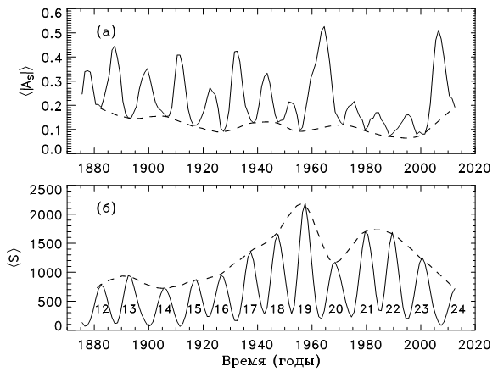
Fig. 1. (a) Absolute north-south asymmetry of average annual values ​​of the total area of ​​sunspots. (b) Total area of ​​sunspots in m.d. The dashed lines curve around the local minima of the absolute asymmetry ⟨| AS |⟩ and the amplitudes of the 11-year cycles ⟨S⟩.

For the sake of clarity of the effect, the dotted curves show the enveloping maxima of the 11-year cycles (Fig. 1b) and the enveloping minimums of absolute asymmetry (Fig. 1a). It can be seen that the curves vary with time in antiphase. Further analysis showed that with increasing asymmetry - the sun can significantly reduce its activity. It is this decrease that we observed in the current 24 solar cycle, which was minimal over the past 100 years. It was observed that such unbalancing in the sun is accumulate for several cycles in the form of an asymmetry of solar activity. If the trend continues, according to our forecasts and the forecasts of other researchers in the sun, there may be a protracted minimum of solar activity, which will naturally affect the earth processes. If the present theories on the influence of solar activity on the climate are correct, then this minimum will lead to a significant cooling, similar to the one that was at the time of “Maunder's minimum”.
Thus, the correlation between the North-South asymmetry of spot-forming and amplitude of the 11-year cycle allows us to predict not only the solar activity, but also to predict events for the earth and near-earth space.
Geoportal technologies to support interdisciplinary research

R.K. Fedorov, A.S. Shumilov
Matrosov Institute for System Dynamics and Control Theory of Siberian branch of Russian academy of sciences (ISDCT SB RAS)
e-mail: shumilov@icc.ru

There is a constant growth of generated, processed and stored information nowadays. The information can be in any form – space images, statistic information, spatial data, large volumes of tabular data, etc. Technologies of information storage mostly offer relational databases and file storage that are often hard to use by experts from fields of science that do not deal with information technologies. Besides the problems of working with stored information, there are also problems of information processing. One of the common approaches to data processing is the use of web-services – atomic software programs that are available through the Internet. The use of services, as well as theirs combination in order to solve complex tasks that constantly arise, is a problem as well.
Geoportal, the software system developed in ISDCT SB RAS, is presented in this work. Geoportal provides tools both for data management and for the organization of service-oriented computing in distributed environment. Geoportal is developed in order to support interdisciplinary research by providing easy-to-use and stable tools for experts.
Geoportal is an open-source web-application that is available on the Internet. It can be shipped and deployed on any server. It has two main modules that deal with data-management and data processing – the tables module and the module of service composition execution. The Geoportal scheme is presented on fig. 1.

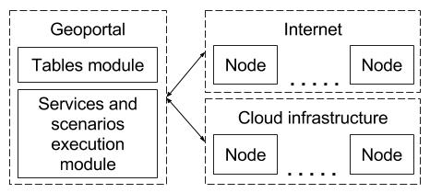
Fig. 1. Geoportal scheme

The tables module provides tools for data input and editing by multiple users. In order to create a table, Geoportal user can define the table name and its columns. Each column has as assigned input element – a special HTML control that simplifies and validates the input. For example, if a table has the column that contains polygon areas, then the corresponding input element will be the interactive selector of specific area on the web map. File columns have the upload input element, regular string columns have text fields elements, etc. Any expert can edit the table with properly defined input elements for its columns. Data import and export in various formats are also available for tables.
The data, managed by the tables module, still need to be processed. In order to provide this functionality, the service composition execution module was developed. The service composition is the set of defined interaction between services that lead to the solution of the complex problem. Geoportal proposes to define services compositions in a form of programs in JavaScript programming language, where services are called using corresponding functions with unique names. Services that are called within the compositions can be dependent on each other, i.e. any input parameter of one service can be a result of execution of another one. Some services that are called in composition can be executed in parallel, so planning of service execution is performed according to the state of the distributed environment (load and status of computational nodes that carry services, duration of service execution on different nodes). The main purpose of the service composition execution module is to hide the execution planning and error handling from user.
Geoportal was successfully probated on a number of tasks from ecology, biology, geography and urban planning. Most of problem that were solved required both the data management and the service composition execution. Groups of researchers from any field of science are welcome to try the developed software system for the solution of complex computational tasks and the problems of data management.

Section 2. Power Engineering and Technology

Improvement of the technique of mathematical
models identification

Alexeyuk V.E.
Melentiev Energy Systems Institute of Siberian branch of Russian academy of sciences (ESI SB RAS)
e-mail: alexeyuk.vitaliy@yandex.ru

The problem of increase in efficiency and reliability of work of the thermal power plants is quite urgent now. Operation personnel needs to have "feedback" in order to increase the efficiency of capital equipment management. It means that we need to trace changes of equipment parameters with the change of control impact. These parameters, which are hard or impossible to measure, are as follows: a consumption of solid fuel, efficiency of the power unit, specific fuel consumption.
It should be noted that current state of the heat power equipment changes during operation. Thus, the problem of estimation of a condition of the capital heat power equipment is important for operational management of working hours of thermal power plants [1].
The solution of the above-stated tasks requires adequate mathematical model of the heat power equipment under study. Such model has to describe in detail real operating modes of the equipment and consider its current state. So, after creation of mathematical model of the heat power equipment it is necessary to set and solve a problem of model identification.
This work is a new stage of research project performed at Melentiev Energy Systems Institute on mathematical models identification of the capital heat power equipment. Previously problems of optimization have been formulated and calculations of a number of heat power installations have been carried out [2–4]. ESI SB RAS developed a computer complex, which ensures optimization calculations of the operation modes of thermal power plants or main heat power equipment. The computer complex is based on methods and software tools for mathematical modeling and optimization of thermal power plants [4]. Also the method of mathematical models identification of the main power equipment based on the results of measurements of parameters in several operating modes was developed. Usually such parameters as consumption, pressure and temperature in various points of the technological diagrams of steam boilers and turbines made during testing of the equipment under study are used.
The object of the present study is the steam turbine plant K-225-12,8-3P. The turbine is a part of the 3rd power unit of Kharanorskaya state district power station. More detailed description of mathematical model and the settlement scheme of the considered turbine plant K-225-12,8-3P is provided in [5, 6].
The problem of identification consists in finding values of the configured coefficients of mathematical model and the measured settings. Calculations are made taking into account the accuracy of the sensors used during tests of the equipment and physical restrictions for operation of the equipment. The structure of the adjusted coefficients of mathematical model is selected individually for each mathematical model. They are necessary for influence on the physical processes happening in the elements of the mathematical model.
The existing technique of the identification described in [1] has been tested. Drawbacks preventing successful solution of mathematical model identification problem have been found.
Firstly, the problem of identification is solved when it is known that among the measured parameters there are no gross blunders of measurement. Gross blunders of measurement are defined as values of those parameters which are outside the declared accuracy of the measuring instruments used during tests. If some measurements are inaccurate, mistakes are redistributed between various parameters and, what is more important, between various operating modes of the equipment. Such redistribution precludes unambiguous defining of wrong measurements and leads to incorrect decisions.
Secondly, the above technique doesn't consider an error of the mathematical model itself. Mathematical models of the capital heat power equipment of thermal power plant are based on standard methods of calculation and do not always describe real processes with sufficient accuracy. It entails additional errors which have to be considered in the course of the solution of an identification problem.
Some strategies aimed at the improvement of the existing identification technique are proposed. It is necessary to break down the problem into 3 characteristic stages (instead of 1 stage in the existing technique) which are solved strictly consistently. And this is the major goal of the current paper.
At the first stage, an optimization task is compiled and solved for each operating mode of heat power equipment separately. This problem consists in minimizing the greatest relative discrepancy of the parameters. The relative discrepancy of the parameters is the difference between the values of the parameters measured at the installation and calculated using a mathematical model, divided by the variance of the error of the measuring instrument used. This provides identifying and excluding erroneous measurements, which hinder further calculations.
The second stage of identification is carried out in a similar way, only it is solved jointly for all operating modes of the heat power equipment. It gives the chance to analyze correctness of creation of the mathematical model, to make necessary changes and also to define values of the coefficients of model which strongly depend on an operating mode.
At the third stage, an optimization task is compiled and solved for all modes jointly. This task consists in minimizing the sum of the squares of the relative discrepancies of the measured parameters in all the operating modes of the equipment. This allows us to achieve the maximum possible convergence of the work of real equipment and calculations of the created mathematical model.
The improved method of performing the identification of mathematical models proposed in this paper improves and simplifies the procedures of detection and elimination of inaccurate measurements of the measured parameters and finding and correcting errors in the mathematical model of equipment. All this makes it possible to improve the accuracy of solving the problem of model identification. A more detailed description of the improved identification technique and the results of calculating the mathematical model of the turbine K-225-12,8-3P is given in [5, 6].
The results of solving the problem of the mathematical model identification of the turbine unit K-225-12,8-3P can be used to solve problems of operational control, state estimation and optimal operation of the power unit and the power plant as a whole.
Bibliography:

1. Rapid assessment of the state of the main equipment of TPP / A.M. Kler, A.S. Maksimov, E.L. Stepanova, P.V. Zharkov // Electric stations. – 2011. – No. 4. – P. 2 – 7.
2. Heat-power systems: Optimization studies / А.М. Kler, N.P. Dekanova, E.A. Tyurina, etc. – Novosibirsk: Science, 2005. – 236 p.
3. Kler A.M., Stepanova E.L., Maksimov A.S. Optimization of the operating modes of the CHP using high-speed mathematical models of steam-turbine heating plants // Thermophysics and Aeromechanics. – 2006. – No. 1, Vol. 13. – P. 159 – 167.
4. Optimization of operating modes of the CHP taking into account the real state of the main equipment / А.М. Kler, A.S. Maksimov, E.L. Stepanova, et al., Heat Power Engineering. – 2009. – No. 6. – P. 50–54.
5. Alexeyuk V.E. Improvement of the method of mathematical models identification by the results of tests on the example of a condensing turbine unit // System studies in power engineering. Proceedings of young scientists ISEM SB RAS, Issue 47. – Irkutsk: ISEM SB RAS.
6. Alexeyuk V.E., Maximov A.S. Identification of the mathematical model of a condensing turbine installation based on test results // Proceedings of the All-Russian Scientific and Practical Conference with International Participation "Increasing the Efficiency of Energy Production and Use in Siberia" April 24 – 27, 2017, – Irkutsk: Izd.

Comparative analysis of the operating modes of the conventional and active-adaptive distribution electric networks
A.S. Voronin
Irkutsk National Research Technical University
e-mail: leichtathlet@mail.ru
Distribution electrical networks are the last link in the transmission of electricity to the final consumer. These medium and low voltage networks, largely with trunk-radial circuits of electrical connections, are the longest networks themselves. Currently, Russia mostly uses centralized distribution of electricity from electric power systems (EPS), the distinctive features of which are as follows:
- Use of two - five wire networks with connection of one-, two- and three-phase electrical receivers to linear and phase voltages, leading to an asymmetric operation mode.
- Unidirectionality of power flows from the power supply system to the electric receivers, except for the overflows of reactive power during overcompensation.
- Separate operation of power supplies to reduce short-circuits currents compared to parallel operation.
- Stepwise distribution of electricity from the supply EPS. If there is no reservation, deactivating of the stage leads to the disconnection of its consumers.
- Simplicity of the circuits, allowing for the execution of switching and emergency shutdowns by using switching devices, which are installed in the head of power lines.
- Ensuring uninterrupted power supply to consumers by automatic devices for reserve entry and re-activation.
- Information and measuring systems do not allow assessing the state of the distribution network. Operation control of the distribution network can use measurements taken only at the substations, at the beginning of each feeder.
- Significant losses of electricity due to its transmission at low and medium voltage.
To improve energy efficiency and reliability of power supply and to improve consumers’ power quality in Russia there was developed the concept of the transition from conventional networks to actively-adaptive networks (AAN) [1]. Technologies of the intelligent power system (IPS) with AAN ensure realization of the new concepts, which include, particularly, micro networks and virtual power plants (VPP) that are created to manage decentralized generating capacities.
A micro network is a network that includes distributed generation sources, energy storage devices and loads with integral control system. A characteristic feature of the micro network is the possibility of its automatic transition to isolated work after an accident in a macro network and automatic restoration of synchronous operation in the network after elimination of an accident while maintaining the required quality of electrical energy.
For the unified management of distributed generators, energy storage devices and consumers-regulators of micro network and a macro network, virtual power plants are created [2]. VPP integrated into the grid as well as into the market of electricity and capacity, will manage the flow of electricity to consumers and the EPS, depending on the circuit-mode configuration of the network, demand and supply at the electricity market.
For the operation of micro-networks and VPP, a "smart" infrastructure is needed: "smart" electricity metering systems, communication, special software that will balance the available sources of electricity and source control devices.
The control system of the micro network and the VPP includes devices for collecting, storing, processing information on available generating capacities, demand, current and forecast, possibilities of unloading flexible power of consumers, and the desired system load graph (usually specified by the System Operator). The VPP software possesses information on available generation and demand in near-real-time mode, and thus determines the most efficient use of sources and control them.
The advantage of VPP is also its very flexible architecture with many different varieties. There may be several VPP and they can be integrated vertically or horizontally. The plant can work separately, or it can be part of an enlarged VPP.
To identify the prospects of using AAN with a micro-network in comparison with the conventional network, there were performed studies based on three-phase estimation [3] of the state for the 15 nodal scheme in Fig. 1.
The analysis was conducted under two conditions:
- Full supply of electricity to consumers.
- The same voltage on the boundary of the distribution network and EPS.
The status of the electric network was estimated according to the specified scheme and parameters of the electric network, the voltage in the first node, the graphs of electric loads and power generation in AAN.
The results of the calculation are shown in the figures 2,3,4,5,6,7.
Figure 1. Electric network: a) conventional network; B) perspective AAN
Figure 2. Minimum and maximum voltage levels in network nodes in the daily time interval: a) in the conventional network; b) in perspective AAN
Figure 3. Voltage magnitudes in the nodes 1, 2, 5, 9, 13, 14 in the maximum load mode: a) in the conventional network; b) in perspective AAN

Figure 4. Power flow in branches in the maximum load mode: a) in the conventional network; b) in perspective AAN

\
Figure 5. Power loss in branches in the maximum load mode: a) in the conventional network; b) in perspective AAN

Figure 6. Dissymmetric coefficients of voltage in nodes in the maximum load mode: a) in the conventional network; b) in perspective AAN

Figure 7. Power consumption from EPS in the daily time interval: a) in the conventional network; b) in perspective AAN
Comparative analysis of the operation modes of conventional and AAN at the same load shows that the use of additional generation in AAN can reduce losses, improve the quality and reliability of electricity supply, but because of the introduction of this generation, power flows become reversible, overvoltages, overloads, and significant load unbalance can occur. This will require the installation of additional control and protection devices and construction of additional communication lines. Nevertheless, the obtained estimates show the potential economic and energy efficiency of the AAN implementation.
Sources
- The basic provisions of the concept of intelligent energy system with active-adaptive network, E. V. Finaev, Russia, 2012
- Optimal Dispatch of Renewable Energy Sources Included in Virtual Power Plant Using Accelerated Particle Swarm Optimization, Daniel Hropko, Ján Ivanecký, Ján Turček, Slovak Research and Development Agency, 2013
- Linear State Estimation in Low Voltage Grids based on Smart Meter Data, Y. M. Atwa, E. F. El-Saadany, R. Seethapathy, Kaiserslautern, Germany, 2016

Cybersecurity of intelligent Power Systems

M. A. Khaptagaev
Irkutsk National Research Technical University
e-mail: matvey1988@yandex.ru

Introduction
In 2012, the Concept of Intelligent power system with active-adaptive network (IPS AAN), an analogue of Smart Grid technology, started to develop in Russia. As part of the IPS, the electric network from the passive device for transmission and distribution of electricity is transformed into an active element whose parameters and characteristics change in real time, depending on the operating modes of the power system [1].
The main innovative technologies of IPS AAN are distributed generation, distributed power storage devices, FACTS technologies, complex conductors, monitoring systems, digital substations [2]. Principles of information cooperation of energy objects used in IPS, include digitization and data exchange in digital form based on IEC protocols between management objects and dispatch centers, lead to increasing threats to cybersecurity.
Here we consider two technologies of IPS AAN the most vulnerable in terms of cybersecurity: Digital Substation (DS) and Wide Area Monitoring System (WAMS).
Digital Substation
Digital substation is substation where the organization of all information flows in the tasks of monitoring, analysis and control is carried out in digital form [3].
The immediate objectives of DS creation are as follows:
- to improve monitoring and management of the power equipment of the substation;
- to increase the reliability and efficiency of operation of the substation equipment;
- to transform the substation into "unattended" one, which works without the permanent monitoring of operational personnel [1].
The transition to digital signaling at all levels of the DS management will provide a number of advantages [1].
Wide Area Monitoring System
The work of a real energy system is always accompanied by so-called transition modes. The transition mode is the change in the parameters of an electrical network from one stable state to another because of the influence of a disturbing factor: the switching off /on of the generator, the line, the load, the short circuit, etc.
Depending on the set of various factors of the system, the transition mode can end with a transition to a steady state or develop into a serious systemic accident. In order to prevent emergencies, the dynamic parameters of the power system are tried using special mathematical models [4].
Any models, including models for analyzing the dynamic properties of the energy system, need verification, when parameters obtained by calculation are compared with the actual parameters of the transient mode measured at different nodes of the power system for the same disturbance. An analysis of the dynamic properties of the electric power system is possible if the parameters at its various geographical points are measured at the same time points. This task is solved with the help of signals Pulse per second sent by space satellites [5].
WAMS is based on the technology of recording Synchronized phasor measurements (SPM) of the parameters of the electric power mode. Phasor measurement units (PMU) are installed at power facility and provide measurement and primary processing of information on the parameters of the electric power mode. Important qualities of SPM are high-precision synchronization of PMU measurements with satellite global navigation systems (GPS / GLONASS) [6].
Threats to cybersecurity of IPS
For reliable uninterrupted operation of electric power systems, reliable baseline data are required. Technical failures or exposure to cyberattacks can lead to partial loss or distortion of these data.
The key elements that can be exposed to a cyberattack with a consequent malfunction of the DS are as follows:
- external digital channels, through which technological and operational communication with other power facilities and dispatching points is carried out;
- communication networks of the power facility, including switches and routers;
- process buses and busbars (in accordance with IEC-61850);
- digital devices of relay protection and emergency automatics, control and monitoring of electrical equipment [7].
WAMS is itself an object of cyberattacks, which lead to falsification, loss, delay and desynchronization of PMU measurements and other negative effects.
The most likely cyberattacks on WAMS are as follows:
- intelligence attacks that allow hackers to identify weaknesses and potential targets in the WAMS architecture;
- attacks of introducing false data, aimed at destruction of integrity, availability and reliability of data or the system's performance;
- denial of service attacks (DoS) [8].
A number of cyberattacks can be directed to the time synchronization subsystem such as:
- spoofing attacks that target synchronization subsystems with GPS;
- replay attacks when the hacker writes down authentic GPS signals and retransmits them with a time delay;
- making interference, in order to stop receiving and tracking GPS signals [8].
Possible Solutions
If all devices of relay protection and emergency automatics, control systems of primary equipment are implemented on a digital basis and combined into a unified information and control system, then the result of cyberattack can be a complete loss of controllability of the power facility or deliberately false control.
If several adjacent substations are exposed to a purposeful cyberattack, then complete de-energization of a significant group of consumers (including those responsible) becomes possible. In addition, there may be cases of damage to expensive primary equipment due to an unsettled fault or prolonged unresolved overload.
Therefore, all possible solutions should be divided into two groups:
- measures to strengthen cybersecurity in order to prevent successful cyberattacks;
- measures to improve the evaluation of telemetry signals received from power facilities with the purpose of timely detection of inaccurate data.
Conclusion
Ensuring the cybersecurity of IPS AAN should be considered a priority task throughout the lifetime of the IPS AAN [1] because an increase in the overall level of IT-based management of the energy sector leads to an increase in the risk of technical and/or economic damage from unlawful actions.
Cybersecurity of IPS AAN is implemented in the form of an integrated information technology that combines the optimal hardware, software and organizational methods for providing cybersecurity, including:
- barrier methods (physical limitation of access, delineation of user rights, passwords, roles);
- traditional means (antivirus and firewall);
- balanced application of open and closed standards of cybersecurity;
- application of two-way public key encryption at the level of the communication protocol (transport layer);
- electronic digital signatures and systems of relevant hosting centers;
- expert tools based on active audit.
References
- The Concept of Intelligent Power System with the active-adaptive network of Russia / edited by: academicians of RAS of Fortov V.E. and Makarova A.A. – Mockow, 2012.
- N.V. Savina. Innovative development of power industry on the basis of SmartGrid technologies: manual / comp. Savina N.V. – Blagoveshchensk: AmurSU, 2014. – 136 p.
- Yu.I. Morzhin. Digital substation of UPS / Morzhin Yu.I, Popov S.G, Gorozhankin P.A, Narovlyansky V.G, Vlasov M.A, Serdtsev A.A. // The Power Expert – 2011. – No. 4 (27). – Page 27-32.
- R.N. Mogilko. A Monitoring System of transient modes for objects of RAO UPS of Russia / Mogilko R.N. // The Power engineering specialist – 2006. – No. 7.
- B.I. Ayuev. About a Monitoring System of Transient modes / Ayuev B.I. // The Power market – 2006. – No. 2
- A.V. Zhukov. Development and deployment of Automatic system of information collection from unirs of a Monitoring system of transient modes in UPS of Russia / Zhukov A.V, Dubinin D.M, Utkin D.N, Gaydamakin F.N, Danilin A.V, Toporkov D.N // Releyshchik – 2013. – No. 3. – Page 18-23
- A.B. Osak. A human factor in case of support of cyber security of Power System facilities / Osak A.B, Panasetsky D.A, Buzina E.Ya // Collection of reports of the international conference "The Modern Directions of Development of Systems of Relay Protection and Automatic Equipment of Power Supply Systems", Sochi, on June 1 - 5, 2015.
- I. N. Kolosok. Authentication of data synchronized vector measurements in cyber attacks on SMPR / I.N. Kolosok, L.A. Gurina // Information and mathematical technologies in science and control – 2017. – No. 1. – Page 19-29

Aspects and problems active consumption systems’ implementing

V.B.Shelekhova
Irkutsk National Research Technical University
e-mail: vsb@isem.irk.ru

An active consumer in intelligent integrated energy system is defined as a consumer that has control over demand by using information about prices, reliability, power system state to minimize costs of buying energy. Active consumer forms and controls demand for purchase/sale of energy and acts as an active player at the energy market.
Modern energy systems presuppose active participation of consumers in their demand formation and realizing operation system modes. It promotes penetration of technology into generation units, smart meters, and devices of control and communication systems. Active consumer is a significant part of an intelligent energy supply system. Modeling of an active consumer is a very challenging task. It involves description of operation centralized system modes and operation micro units modes, demand response, uncertainty in consumers’ behavior. In the case of RES, the issues of its generation have to be considered. Generally, introduction of active consumer concept will enable increase in energy system reliability and decrease in consumers’ operation costs. With IT penetration into everyday life, the demand response potential becomes more powerful and use of this potential for establishing bilateral ties between consumers and centralized system becomes more significant.
The difference between conventional customer and active consumer of thermal energy is presented in Fig.1. The active consumer differs from conventional consumer by the ability to control his demand.
This paper addresses the possibility of ensuring demand by various types of energy carriers and active consumer of thermal energy within two demand response programs.
Customer behavior is a result of many social and other factors and is represented by a stochastic variable. Making active consumer model closer to reality, uncertainty associated with customer response on suggested programs has to be considered.
Naturally, that consumer has to be available to participate in various demand response programs. The programs developed in [1] were considered and adopted.
- carrier-based demand response – optimal demand distribution between energy carriers generators based on minimized consumer operational costs.
- carrier share – optimal demand distribution between generators based on centralized energy system interests. This program subtends planning of consumption.
Active consumer of thermal energy
Local district energy
System

Local district energy
System

Heat supply system
Demand
Comfort level
Consumer
Consumer demand

Fig. 1 – The difference between conventional customer and active consumer of thermal energy
Energy system model
In order to show an application of proposed model, a local network model is shown in Fig.2, with coal-fired power plant, gas-fired power plant, thermal energy storage and adsorption chiller, the active consumers using electrical and gas boilers. It is assumed that each active consumer has possibility to use both electric boiler, and gas boiler.
In the light of the problems indicated, the contributions of this paper are threefold:
- supplying of active consumer demand on thermal energy considering minimum his operational costs.
- impacts of active consumer on demand distribution between different types of supplying systems.
- assess the stochastic behavior of the demand side for selecting the carriers by implementing scenarios incorporating programs.
Energy hub model
In order to extend the degrees of freedom in heat supplying variation, each element of matrix will be described by two parameters. The first one is coefficient of energy conversion and the second one is decision variables.
The structure of energy hub is represented in Fig. 2.
The input carriers of the system are coal, gas and electricity, while outputs are electricity, thermal energy, cold and thermal energy produced by active consumers.
The objective function in operating this system is to minimize the costs of providing the required amount of coal energy input $y_{t,s}$, gas energy input $g_{t,s}$ and electrical energy input $w_{t,s}$, taking into account the costs of energy $p_{y,t}$, $g_{t,s}$ and $p_{e,t}$ for coal, gas and electricity, respectively.
This model has been formulated to obtain the mean value of total fuel costs for all scenarios of consumer response.
HS
Chiller
CHP on gas
CHP on coal

Fig. 2 – energy hub
- Stochastic Modeling of Multienergy Carriers Dependences in Smart local Networks With Distributed Energy Resources. Nilufar Neyestani, Maziar Yazdani-Damavandi and others. IEEE transaction on smart grid. 2015, July,4.
- Aldo Bischi, Leonardo Taccari, Emanuele Martelli, Edoardo Amaldi, Giampaolo Manzolini, Paolo Silva, Stefano Campanari, Ennio Macchi. A detailed MILP optimization model for combined cooling, heat and power system operation planning. Energy, 2014, xxx 1-15.
- Risto Lahdelma, Henri Hakonen. An efficient linear programming algorithm for combined heat and power production. European Journal of Operational Research xxx (2003) xxx–xxx.

Section 3. Life-sciences on the Cutting Edge of Science

Exploring strategies for genetic manipulaton of plant mitochondrial genomes
T.A.Bolotova, V.I. Tarasenko, E.S. Klimenko, Y.M. Konstantinov, M.V. Koulintchenko,
Siberian Institute of Plant Physiology and Biochemistry, of Siberian branch of Russian academy of sciences (SIPPB SB RAS)
e-mail: bolotova_t.a@mail.ru

The plant mitochondrial genome is very dynamic and flowing, its structure suggests multiple origins of its constituent genetic sequences. Many aspects of the structural and functional organization and regulation of the mitochondrial genomes expression are poorly understood. This is due, in particular, to impossibility of the mitochondrial genes manipulation because of the lack of the mitochondria genetic transformation system, such as it was developed for nucleus and chloroplasts. Creating such a system is an important task not only in terms of the fundamental research, but also of its potential practical applications. The in vitro DNA transformation of the mitochondria from different species of the multicellular eukaryotes was attempted by different research groups using of various artificial systems and DNA carriers. With participation of our laboratory coworkers, a phenomenon of natural competence of the mitochondria of plants, animals and yeast for the DNA uptake had been discovered. In search of the ways for the mitochondrial transformation in vivo, some results were obtained, but the major achievement in this direction so far is limited with the mitochondria from unicellular organisms, Chlamydomonas reinhardtii and Saccharomyces cerevisiae [1, 2, 3]. The main obstacles of the mitochondrial transformation in vivo are (i) their small size (compared with the chloroplasts), (ii) the absence of a selective gene, which would allow to select cells containing transformed mitochondria, (iii) the presence of a large mitochondria population in the cell and of many mtDNA copies in each mitochondria.
Our approach is aiming to explore the possibility of plant mitochondrial transformation using the Arabidopsis mutants with mitochondrial dysfunctions. Such a dysfunction must not be lethal for the organism, but manifested in a particular phenotypic, ontogenetic and / or molecular level. The mitochondrial mutant plants and/or suspension cell cultures have often delayed growth and development. The genetic constructs containing the selective gene, which can restore the mitochondrial functionality under the control of the regulatory sequences specific for the mitochondrial genetic system, is used for plant transformation. The transformed mitochondria within the cell and / or cells harboring mainly the transformed mitochondria have selective advantage over the non-transformed mitochondria / cells carrying the defect resulting in a slower growth.
The development of a system which would favour the effective transfer and foreign genes stable expression in mitochondrial genome of the whole organism is a fundamental scientific problem. The solution of this problem will create an experimental basis for the mitochondrial genome manipulation in vivo. Such a system may subsequently be used both in fundamental research of the genetic processes involving the mitochondrial genome, and in biotechnological studies on mitochondrial expression of genes valuable with the respect to the agriculture and control of the genetically modified organisms spread. The positive results obtained can also be used as a theoretical basis to search for approaches of the gene therapy of mitochondrial diseases.
References
- Fox T.D., Sanford J.C., McMullin T.W. Plasmids can stably transform yeast mitochondria lacking endogenous mtDNA.Proc. Natl. Acad. Sci. USA. 1988. V. 85. No. 19. P. 7288-7292.
- Johnston S.A., Anziano P.Q., Shark K., Sanford J.C., Butow R.A. Mitochondrial transformation in yeast by bombardment with microprojectiles. Science. 1988. V.240. P. 1538-1541.
- Remacle С., Cardol P., Coosemans N., Gaisne M., Bonnefoy N. High-efficientcy biolistic transformation of Chlamydomonas mitochondria can be used to insert mutations in complex I genes. PNAS. 2006. V. 103. No. 12. P. 4771-4776.

Content of ascorbic acid in apple fruits of Siberian crabapple, domestic apple and their hybrids grown in Siberian conditions
A.A. Shishparenok
Siberian Institute of Plant Physiology and Biochemistry of Siberian branch of Russian academy of Science (SIPPB SB RAS)
email: sansanich90@inbox.ru

Introduction
Industrial gardening in our region is poorly developed because of the cold continental climate. There are big variation in daily temperature, up to 30 degrees; drought in early summer and heavy rains in July and August. During flowering there are often short night frosts, which can damage the flower buds. The growing season is variable and ranges from 80 to 125 days. The cultivars of domestic apple die during first 2-3 years due to the accumulation of winter and early spring damages. To avoid such damages, the growers widely use hybrids of Siberian crabapple and domestic apple.
Siberian crabapple (Malus baccata L) is the most frost-hardy Malus species. The trees can bear the lowering of the temperature up to -50 ° C. Since this apple has high plasticity, it forms a large number of ecological forms.
We found several promising dwarf and super dwarf (1.5 m.) trees in our field studies. These plants are studied and used to create new dwarf apple rootstocks. When used as a rootstock, Siberian crabapple impacts mostly frost- and cold resistance and accelerates fruiting, a year after the grafting. It is interesting that the high adaptability of Siberian crabapple allows it to be introduced in more contrasting climatic conditions, for example, India and Iran. Siberian crabapple is often used in plant breeding to increase winter hardiness.
As far as we found before, Sibirian crabapple has specific biochemical features.
Thus, the aim of our work was a comparative analysis of the accumulation of ascorbic acid in apple fruits of Siberian crabapple (Malus baccata L.) and its hybrids with domestic apple.
Materials and methods
All varieties used in our study have been grafted on trees of Siberian crabapple and grown on experimental plot of our Institute in Irkutsk.
For identification of ascorbic acid was used method of titration. To determine is taken 5 grams of apple sample. Samples are ground in a mortar with 20 ml of hydrochloric acid. The resulting homogenate is poured into a 100 ml volumetric flask. The mortar is rinsed several times with 1% oxalic acid, which is poured into the same flask. The content of the flask is toped up to a mark with 1% oxalic acid and closed with a stopper, shaken vigorously and allowed to stand for about 5 minutes. The contents of the flask are then poured onto a dry filter and a portion of the extract (about 50 ml) is filtered off into a dry beaker or flask.
To titrate the extracts from the obtained filtrate, take two equal portions of 10-20 ml each by pipetting, pour into a 50 ml beaker and titrate from the microburette with 0.001 normality paint solution (2,6-dichlorophenolindophenol) until a clear-pink staining, which does not disappear for 0, 5 - 1 minutes.
Results and discussion
Important antioxidant with low molecular weight is ascorbic acid, which content increases in the plant tissues under biotic and abiotic stress, including the excessive insolation.
As far as the localization of ascorbic acid in apples is concerned, the content of ascorbic acid varies widely. The table 1 presents the distribution of vitamin C for the studied species and varieties. The data on the content on fresh weight, dry weight, and the ratio of ascorbic acid content in the peel to the content in the pulp. In this case, the ratios of its contents in the pulp and in the peel (dry weight) of the domestic apple and its hybrids are much lower than those of Siberian crabapple. As it can be seen, some varieties of domestic apple have very high vitamin C content in the pulp.
Cultivar | Species | Vitamin C in peel, µg g-1 FW | Vitamin C in flesh, µg g-1 FW | Vitamin C in peel, µg g-1 DW | Vitamin C in flesh, µg g-1 DW | Peel/flesh, DW
Siberian Crabapple | M.baccata | 184.1±32.7 | 7.1±0.9 | 455.4±37.2 | 20.6±1.8 | 22
Palmetta | F1 | 134.4±14.2 | 40.8±1.3 | 581.6±28.3 | 83.3±1.4 | 7
Siberian Souvenir | F1 | 101.3±18.2 | 21.6±1.3 | 398.9±32.4 | 154.0±10.7 | 2.6
Altayskoe rumyanoe | F2 | 31.2±4.1 | 3.3±0.1 | 144.9±8.6 | 29.8±0.9 | 3.9
Podruga | F2 | 60.3±1.3 | 3.8±0.1 | 232.0±16.2 | 30.2±1.0 | 7.7
Anis sverdlovskii | F3 | 10.1±1.1 | 1.3±0.0 | 37.2±4.7 | 10.5±0.3 | 2.33
Lada | F3 | 55.3±4.8 | 10.1±0.8 | 212.6±18.4 | 83.7±7.6 | 2.6
Nejenka | F3 | 7.5±0.9 | 2.5±0.1 | 23.9±3.8 | 20.9±0.6 | 1.1
Antonovka | M.baccata | 20.1±2.1 | 5.7±0.6 | 97.1±8.5 | 47.1±0.8 | 1.9
Melba | M.baccata | 11.2±0.1 | 1.3±0.0 | 41.6±3.8 | 10.5±0.1 | 3.9
Sokovoe 3 | M.baccata | 10.1±1.2 | 2.5±0.1 | 38.7±3.2 | 25.1±1.2 | 1.6
Phoenix Altayski | M.baccata | 1.9±0.1 | N/D | 6.8±0.4 | N/D
Chudnoe | M.baccata | 5.1±0.1 | 1.3±0.0 | 25.7±0.5 | 10.5±0.2 | 2.5
Table 1. Content of ascorbic acid in apple fruits.
In this table, we can see that the peel of Siberian crabapple fruits is an undisputed leader in the accumulation of ascorbic acid (184.06 ± 32.66 µg / g). The high content of vitamin C in the fruit is preserved in the first generation of hybrids (Palmetta and Siberian Souvenir), both in the peel and in the flesh. The content of ascorbic acid decreases by reducing the proportion of genes of Siberian crabapple in generations, and depends on the variety. Our studies have shown that high level of ascorbic acid in the fruit of Siberian crabapple is a result of high activity of dehydroascorbate reductase but not because of its de novo synthesis (figure 1).
Figure 1. Activity of dehydroascorbate reductase of apple fruits.
We would like to draw your attention to the fact that, unlike the domestic apple and its hybrids, the major part of ascorbic acid in the Siberian crabapple is accumulated in the peel. In terms of ascorbic acid content in mg% for the whole Siberian crabapple fruit, we got the modest value - from 7 to 12 mg%. However, higher content was often pointed out in the published data. In this table, we summarize the published data on the content of ascorbic acid in different parts of the world (table 2). We used the published data to calculate the values which are marked by an asterisk. Of course, it’s necessary to be aware that vitamin C content in plant tissues can fluctuate significantly over the years in response to growing conditions, but in general, we can observe certain regularity.

Region | Vitamin C content, mg% | Soluble solids, % | Vitamin C content, µg g-1 FW in fruts | Article
Poland (Warshava) | 42±3 | 17.3±1.9 | 2430* | Hallmann E. et. al. (2011) Vegetable Crops Research Bull. 75
Ukraine (Kiev) | 15.36 | 30 | 512* | Еremenko М.М. (1964) Dissertation abstract
European Russia (Belgorod) | 21.7 | 61 | 356* | Ivanova S.A. et al. Modern problems of science and education, №4, 2014
Irkutsk | 7-12 | 39.5±0.9 | 177-304 | Rudikovskaya et al. Acta Physiol. Plant. (2015) 37:238
Buryatia (introduce) | 6-7 | 31.3±0.5 | 192-224 | Rudikovskaya et al. Chem. Natur. Compounds (2014) V. 50 (4)
Buryatia (natural) | 1-2.6* | 15 | 10-32* | Bakchanova et al. News КrasGАU (2014) №9
Yakutia | 35±0.2 |  |  | Sarabaykina S.М. Modern problems of science and education (2011) № 6
India (the foothills of the Himalayas) | 820 |  | 73600 | Sharma R., Proc. Natl. Acad. Sci., India (2015)
Table 2. Content of ascorbic acid in different parts of the world.
The lowest concentration of ascorbic acid was observed in natural populations of Siberian crabapple growing in the Republic of Buryatia (10-32 µg / g dry weight). Ascorbic acid content in the fruit can increase by an order of magnitude (up to 304 µg / g dry weight) after the introduction of these trees in the neighboring region of Buryatia (about 100 km) and in the neighboring Irkutsk region (600-800 km).
Looking at the data in a geographically wide context, you can observe the following picture. Ascorbic acid content steadily increases with the increased distance from the natural habitat. It forms a geographic cline. Content of vitamin C rises to the west (Belgorod → Kiev → Warsaw (уосо), & northeast (Yakutsk) & and the south (the Himalayan foothills, India). There it reaches the maximum value (73 600 mg / g dry weight).
According to the results of Professor Sedov, the reverse pattern was observed for the cultivated apple. Ascorbic acid content increases with the promotion along Europe to the north and east. The information about interspecific hybrids is rather fragmented but it allows noting that, for example, fruits grown in Irkutsk (East Siberia) contain vitamin C is 2-3 times less than in the regions (Western Siberia), where they have been selected.
The reason for this phenomenon is unknown as yet. First, we thought that lighting played a decisive role here. But the fruits of the Siberian apple tree in Poland have accumulated more vitamin C than those in Irkutsk and Buryatia, while the light levels are approximately the same in these places. The temperature also may not be the primary reason. As ascorbic acid content in Yakutia is the closest to those in Poland, which is located in more temperate climate. This phenomenon may be complex by its nature and it needs further clarification.
References
- Bakchanova et al. News КrasGАU (2014) №9
- Еremenko М.М. (1964) Dissertation abstract
- Hallmann E. et. al. (2011) Vegetable Crops Research Bull. 75
- Ivanova S.A. et al. Modern problems of science and education, №4, 2014,
- Rudikovskaya et al. Chem. Natur. Compounds (2014) V. 50 (4)
- Rudikovskaya et al. Acta Physiol. Plant. (2015) 37:238
- Sarabaykina S.М. Modern problems of science and education (2011) № 6
- Sharma R., Proc. Natl. Acad. Sci., India (2015)

Role of tetrapyrrole synthesis-mediated signals in GDH1 and GDH2 genes expression in Arabidopsis thaliana

V.I. Belkov, E.Yu. Garnik, Yu. M. Konstantinov
Siberian Institute of Plant Physiology and Biochemistry of Siberian Branch of Russian academy of science (SIPPB SB RAS)
e-mail: anvad.irk@rambler.ru

There are many nuclear genes with light-depended regulation of expression in plants. Glutamate dehydrogenase genes named GDH1 and GDH2 are two of these genes. The enzyme participates in amino acid metabolism and catalyze deamination of glutamate to 2-oxoglutarate. Expression of GDH1 and GDH2 genes is higher in the dark and lower in the light. Double mutant gdh1gdh2 of Arabidopsis (Arabidopsis thaliana) has less viability than wild type plants. There is a hypothesis that expression of GDH1 and GDH2 genes depends on carbohydrates level, which is higher in the light and lower in the dark. Nothing is known about possible participation of chloroplast-to-nucleus (retrograde) signals in GDH1 and GDH2 genes expression (tetrapyrrole synthesis-mediated signals, for example). The goal of the work is to study the role of tetrapyrrole synthesis-mediated signals in GDH1 and GDH2 genes expression.
Tetrapyrrole synthesis-mediated signals are well studied in genome uncoupled mutants (gun mutants) of Arabidopsis. The light-dependent genes are expressed in gun mutants without functional chloroplasts as contrasted with wild type plants, so these mutants have no chloroplast-to-nucleus genes expression coordination.
We have compared gun mutants with wild type plants of Arabidopsis on the growth medium supplemented by 2% sugar and 5 mcM norflurazon. Norflurazon provides chloroplast destruction at light. Transcripts level of GDH1 and GDH2 genes was estimated by polymerase chain reaction after reverse transcription (RT-PCR).
We have demonstrated that light-dependent regulation of GDH1 and GDH2 genes expression in gun1 and gun1gun5 mutants is mediated by chloroplast-to-nucleus signals, not by phytochromes or cryptochromes. Compensation of photosynthesis lack in studied plants (grown on norflurazon) by sucrose supplementation in grow medium did not lead to repression of the studied genes as in the control conditions. We conclude that tetrapyrrole synthesis-mediated signals probably do not affect GDH1 and GDH2 genes expression.

The study of microorganisms of the nitrogen cycle in Lake Baikal

G.V.Podlesnaya
Limnological Institute Siberian branch of Russian academy of science
(LIN SB RAS)
e-mail: podlesnaya@lin.irk.ru

The nitrogen cycle is one of the major biogeochemical cycles of our planet. Nitrogen is a biophilic element. It is a part of simple and complex molecules of all living organisms. The total productivity of the pond and the water quality depends on the amount of nitrogen compounds. The main transformations of nitrogen compounds are carried out by microorganisms such as nitrogen fixers, nitrifiers and denitrifiers.
Biological nitrogen fixation is the main source of nitrogen in oligotrophic ecosystems. The first diazotrophic microorganism was discovered among the anaerobic oleaginous bacteria of the genus Clostridium by S.N. Vinogradsky at the end of the 19th century. It is now recognized that there are different species of bacteria capable of fixing molecular nitrogen. They occur both under aerobic and anaerobic conditions.
Nitrification is a two-step process which involves two different groups of bacteria. Ammonia-oxidizing bacteria oxidize ammonia to nitrite and nitrite-oxidizing bacteria oxidize nitrite to nitrate.
The first phase of nitrification is performed by nitrosobacteria being representatives of the genera Nitrosomonas, Nitrosococcus, Nitrosolobus and others. The second phase is carried out with nitrobacteria. Nitrobacteria are polyphyletic. They belong to the classes of alpha-, gamma- and delta-Proteobacteria, as well as to fillets of Nitrospirae. Some heterotrophic bacteria and fungi can also oxidize ammonia to hydroxylamine, nitrite and nitrate.
Denitrification is the process leading to depletion of the pond in nitrogen. In the process of denitrification, the nitrates are reduced through the intermediate products (NO₂, NO, N₂O) to molecular nitrogen. The denitrifying microorganisms return nitrogen to the atmosphere, ensuring a constant nitrogen cycle. The denitrifying ability is widespread among bacteria of unrelated systematic affliations. These predominantly heterotrophic microorganisms are facultative anaerobes that are able to use NO₃ instead of oxygen as an electron acceptor in respiration to cope with low-oxygen or anaerobic conditions.
Most microorganisms form a community that is a biofilm. Microbial biofilms in oligotrophic media usually are prevailing in the littoral zone and are the most reactive component of the ecosystem. They are a kind of "a city of germs". This city is characterized by a complex structural organization, a high number of bacteria and a variety of species composition. In aquatic ecosystems microorganisms carry out the key processes of the nitrogen cycle.
Lake Baikal is the oldest and deepest freshwater oligotrophic lake in the world. During the recent years, the large-scale crisis has been registered in the coastal zone of the lake Baikal. Scientists have identified a massive development of the alien algae of the genus Spirogyra, unusual for Baikal lake, and sponges have also been noted. Сyanobacteria in large numbers began to develops on sponges and on various substrates. These changes are supposed to be due to the progressive eutrophication of the coastal zone of the lake [Timoshkin, 2016].
It is to be noted that in Lake Baikal the microbiological processes of the transformation of nitrogen compounds have been little studied. In this regard, the study of bacteria that take an active part in the nitrogen cycle is particularly relevant.
The aim of my work is to examine the number and taxonomic diversity of the microorganisms of the nitrogen cycle in biofilms of Lake Baikal.
Recently, I have done a research into the detection of strains involved in the nitrogen cycle in the cultured microbial community of biofilms of Lake Baikal. For this the biofilm microorganisms of the littoral zone of the lake Baikal were grown on appropriate nutrient media. The results obtained showed a sufficiently high amount of nitrogen fixers, nitrifiers and denitrifiers in the biofilms of Baikal lake.
For further research I am planing to apply classical methods and techniques of molecular biology for the more detailed study of the processes of transformation of nitrogen compounds in the littoral zone of Lake Baikal.

Evaluation of DBP and DEHP in Baikal waters

T. A. Babenko
Limnological Institute Siberian branch of Russian academy of science
(LIN SB RAS)
e-mail: krom_07@lin.irk.ru

A special control of persistent organic pollutants (POPs) in the environment is necessary for the sources of drinking water including Lake Baikal. The deterioration of the ecological condition of the littoral zone of Lake Baikal is a pressing problem. In this situation, the question of possible changes in the levels of pelagic water pollution by POPs in the modern period remains open considering the absence of systematic monitoring POPs in Lake Baikal water.
Therefore the aim of the work was to monitor the upper and depth horizons of Baikal water and to determine two priority esters o-phthalic acid of DBP and DEHP.
Esters phthalic acid are widely used as plasticizers of plastics. In the polymer matrix the plasticizers are not chemically bound so directly or indirectly during production, exploitation and utilization of polymeric material they go into the environment. Studies of the biological activity of phthalates indicate their apparent toxicity, the impact on human health, on the reproductive function in particular and also on the carcinogenic properties of this class of compounds.
During the observation period of 2015-2016 the total phthalate content in the upper water layer of the Baikal pelagial is recorded in a wide concentration range from <0.03 to 3.7 ug/l. The maximum concentrations of phthalates were found in samples collected in the spring of 2016 in southern and middle Baikal. On Listvyanka-Tanha section the total content of phthalates was registered in the interval 2.1 to 3.4 ug/l near the western shore, with the dominant contribution being made by DBP.
The water sample collected in the spring of 2015 was characterized by a lower level of phthalates and a higher relative content of DEHP. In the northern lake basin (station 13-18) the phthalate concentration in the upper water layer is estimated by a narrow range of the phthalate sum from 0.33 to 0.66 ug/l and in the series of samples 2016 (spring) the content of DEHP corresponded to the level of the lower limit of the determination of the concentration (from <0.03 to 0.04 ug/l). When phthalates were monitored in autumn 2016 the fixed concentrations of phthalates were substantially lower their level established during monitoring in the spring of 2016. And the supply of concentration was associated with a sharp decrease in the DBP content. In the northern basin of the lake only DBP was found in minimum quantities of no more than 0.2. ug/l. A higher phthalate content in samples collected in the spring than that of in the autumn seems to reflect the accumulation of pollutants on the ice (in the ice) of the lake, in snow cover on the coast in the cold season and their flow into the lake during the melting of ice and snow. The subsequent decrease in phthalate concentration is evidently the result of their biodegradation and photolysis.
A wide range of concentrations of DBP and DEHP found in the upper and deep horizons of Baikal at the background stations of the reference section indicates a high heterogeneity in the distribution of phthalates. Monitoring of the upper water layer (<200 m) reflects a present level of pollutant concentrations in lake water. Based on this, the average concentration of phthalates in the upper water layer (5-200 m) can be taken as the level of DBP and DEHP in the Baikal basins at the present stage. Despite the extreme concentrations fo DBP fixed in the spring of 2016 the content of phthalates does not exceed the maximum permissible concentrations that are set for these pollutants.
Systematic studies of the phthalate content in Baikal water have not previously been carried out except for the work evaluating the distribution of DEHP in the water horizons in the southern basin. According to the results obtained the concentration of DEHP on horizon 400 remained practically unchanged but for the upper water layer and at the depth of 1200 m they decreased.
In comparison with the data available the average concentrations of the sum of phthalates in the upper water layer are comparable to their minimum content in the water of China lakes and the rivers of Western Europe.

The effects of intense acoustic stimulation on the auditory behavuor and epithelium ultrastructure of baikal fish
Sapozhnikova, Yulia P.¹, Kulikov, Viktor A.², Makarov, Mikhail M.¹, Glyzina, Olga Yu.¹, Yakhnenko, Veronika M.¹, Sukhanova, Lyubov V.¹
¹ Limnological Institute Siberian branch of the Russian academy of sciences, Irkutsk,
² Institute of Automation and Electrometry Siberian branch of the Russian academy of sciences, Novosibirsk,
e-mail: jsap@mail.ru

The study of the acoustic behavior of fish is immensely important due to the increasing levels of sound pollution in the recent years. The consequences of it on fish hearing both in the natural habitat and aquaculture are still largely unknown. We carried out a comparative analysis of morphological characteristics of the hearing apparatus of different species of two groups of Baikal sculpins (Cottoidei) and whitefish (Coregonus sp., Coregonidae) who live in different environmental conditions. Ultrastructural and functional characteristics of the auditory epithelium (hair cell types, distribution, range of maximum acoustic sensitivity, audibility thresholds) were examined in order to correlate it with the differences in the behavioral activity of these Baikal fish. Our main finding was that the intense acoustic stimulation caused variable degree of hair cell damage depending on the area of the macula, confirming the existence of regions with different tonal specialization in the auditory maculae of Baikal fish. The acoustic impact included not only mechanical damage to the sensory epithelium, causing temporary (and possibly permanent) hearing loss, but also a violation of the normal fish behavior, correlating with the acoustic signal intensity. Our work demonstrates that fish are very sensitive to environmental changes, and this entails adaptations at all structural levels: both at level of the cell and the organism as well as at level of populations and species. This work was performed at the Baikal Joint Instrumentation Centre and in the Unique Scientific Installation “Experimental freshwater complex of Baikal aquatic organisms” with the support of the State Project VI.50.1.4 (№0345-2016-0002).

Heterocyclization of α-hydroxyphosphine oxides: phosphorus halides free synthesis of benzophosphorinane-2-ones

Y.I. Litvintsev
A.E. Favorsky Irkutsk Institute of Chemistry
Siberian branch of Russian academy of science
(IIN SB RAS)
e-mail: litvincev_1991@mail.ru

Much attention is being given nowadays to the study of phosphorus-containing heterocyclic compounds.¹ Benzophosphorinanes and their oxides have been of interest as promising ligands for metal complex catalysts inducing many types of transformations.^{1a,c} Also they are of interest as complexing agents in the anti-corrosion compositions,^{1d} antistatic components,^{1e} additives to electrolites^{1f} and building blocks for the design of electroluminescent materials^{1g,h} or solar panels.^{1i}
At the same time, the known routes to benzophosphorinane core^{1b,c,2} are based on malignant and aggressive phosphorus halides and organometallic compounds, which handling requires special conditions, techniques and equipment. For instance, benzophosphorinane-1-ones have been recently prepared from β-hydroxyphosphine oxides, which synthesis is multistep and requires the use of phosphorus halides and n-BuLi² Therefore, the development of an expedient strategy for the PCl₃-free synthesis of benzophosphorinane oxides in the absence of flammable organometallic reactants is a challenge.
In this paper, we describe a facile method for synthesis of benzophosphorinane-2-ones via intramolecular heterocyclization of available α-hydroxy-(2-arylethyl)phosphine oxides, now easily prepared from red phosphorus (via phosphine/hydrogen mixture), styrenes and aldehydes³. The heterocyclization has been carried out by heating (80 ºC, 10-20 h, chlorobenzene) of α-hydroxyphosphine oxides 1a-c in the presence of FeCl₃, the yield of benzophosphorinane-2-ones 2a-c synthesized by this way being 53-60% .
The initial hydroxyphosphine oxides 1a-c have been synthesized according to the Scheme 2, which includes: generation of phosphine (together with hydrogen) from red phosphorus in aqueous KOH/toluene suspension and its further use without isolation and purification for phosphination of styrenes 3, 4 in the presence of KOH/DMSO(H₂O) superbase system.³ The bis(2-arylethyl)phosphines formed by this way in the yield up to 87% are easily transformed (in the air) into the corresponding phosphine oxides 5, 6. The latter react with aldehydes 7, 8 under mild conditions (20-60 ºC) to afford tertiary α-hydroxy-(2-arylethyl)phosphine oxides 1a-c in high yield.
In conclusion, an expedient strategy for the PCl₃-free synthesis of a novel group of benzophosphorinanes, namely, benzophosphorinane-2-ones, from red phosphorus, styrenes and aldehydes has been developed. The target benzophosphorinane-2-ones are promising ligands for metal complex catalysts and intermediate for design of luminescent and optic materials. The results obtained contribute to the chemistry of both elemental phosphorus and phosphorus-containing heterocycles.
References
- (a) D. G. Hewitt, in Comprehensive Heterocyclic Chemistry II, 1996, 5.12, 639; (b) M. J. Gallagher, in Phosphorus-Carbon Heterocyclic Chemistry, 2001, 5.1-5.2, 463; (c) G. L. Edwards, M. Balasubramanian and R. Murugan, in Comprehensive Heterocyclic Chemistry III, 2008, 7.12, 1003; (d) A. W. Phelps and J. A. Sturgill, PCT Int. Appl. Patent WO 2004009869, 2004; (e) M. Miyagi, H. Yauchi and Y. Soneta, Japan Patent 2009029857, 2009; (f) D. G. T. Morimoto, K. Hiratsuka, Y. Sanada and H. Ariga, Japan Patent 63305508, 1988; (g) T. Hatakeyama, S. Hashimoto and M. Nakamura, PCT Int. Appl. Patent WO 2010104047, 2010; (h) Y. Qiu, H. Fan, J. Li and Y. Li, China Patent CN 103183711, 2013; (i) H. J. Lee, Y. J. Cho, H. J. Kwon, B. O. Kim, S. M. Kim and S. S. Yoon, Eur. Patent Appl. EP 2145936, 2010.
- M. Stankevic, K. Wlodarczyk, M. Jakhinska, R. Parcheta and K. M. Pietrusiewicz, Tetrahedron, 2011, 67, 8671.
- B. A. Trofimov, L. Brandsma, S. N. Arbuzova, S. F. Malysheva and N. K. Gusarova, Tetrahedron Letters, 1994, 35, 7647.

Silver and Gold Nanocomposites based on Copolymers

A.A. Ivanova, A.S. Pozdnyakov, T.G. Ermakova, G.F. Prozorova
A.E. Favorsky Irkutsk Institute of Chemistry
Siberian branch of Russian academy of science
(IIN SB RAS)
e-mail: anastasiia_i93@bk.ru

Studying polymer nanocomposites is one of the most popular areas of nanotechnology. These compounds demonstrate synergism of the priority properties of polymers (solubility, biocompatibility, high coordination ability, etc.) and metallic nanoparticles (optical, biological, catalytic), which opens the possibility for practical application.
The present work is devoted to the synthesis and investigation of new water-soluble polymeric silver- and gold nanocomposites based on copolymers of 1-vinyl-1,2,4-triazole with N-vinylpyrrolidone.
Polymer nanocomposites with silver nanoparticles based on water-soluble copolymers of 1-vinyl-1,2,4-triazole with N-vinylpyrrolidone, synthesized under conditions of radical development in DMF medium were obtained by chemical reduction of silver ions from silver nitrate with sodium borohydride.
Nanocomposites are dark brown powders that are readily soluble in water at a silver content of more than 10% in nanocomposites. In electronic spectra, a plasmon absorption band appears with a maximum at 403-423 nm, which indicates the formation of metallic nanoscale silver.
Dispersion of nanoparticles by size depends on the silver content in nanocomposites and ranges from 1-5 nm (Ag, 4%) to 1-12 nm (Ag, 12%). Nanocomposites are thermally stable to 280-300 ° C.
Nanocomposites synthesized have a high antimicrobial activity against both gram-positive and gram-negative bacteria .Minimum inhibitory and bactericidal concentrations are 0.5-8 and 0.5-16 μg / ml, respectively.
Synthesis of gold nanocomposites in the copolymer matrix was carried out under similar conditions by reduction of gold ions from the aurichlorohydric acid. Hydrozene hydrate was used as the reducing agent.
Nanocomposites are dark-cherry powders that are soluble in water regardless of the metal content in the matrix.
A band of plasmon absorption appeared in the optical absorption spectra of nanocomposites solutions is characteristic for systems with isolated zero-valent gold particles with a maximum range of 529-534 nm.
The transmission electron microscopy of the nanocomposite stabilized by an equimolar copolymer shows that the gold nanoparticles are distributed in the polymer matrix uniformly bimodal: the main fraction with sizes from 2 to 3 nm contains 93% of nanoparticles.
Study of polymer nanocomposites is the interdisciplinary field of nanotechnology, which combines a number of scientific areas. Therefore, researches into the synthesis and properties of new nanocomposites based on functional nitrogen-containing copolymers are of current interest and promising.
The work was supported by the Russian Foundation for Basic Research (project № 15-03-08295).

Copolymerization of 1-Vinyl-1,2,4-Triazole with Allylamine

Sekretarev E.A., Pozdnyakov A.S., Prozorova G.F.
- E. Favorsky Irkutsk Institute of Chemistry of Siberian branch of Russian academy of science (IIC SB RAS)
e-mail: sekretaryov@irioch.irk.ru

Polymers containing in their composition nitrogen-containing heterocyclic fragments are one of the most promising classes of high-molecular compounds. Among them of particular interest are copolymers of 1-vinyl-1,2,4-triazole, which, depending on various comonomer fragments, are capable of possessing complex of valuable properties such as high solubility (including hydrophilicity), complexation and quaternization abilities, chemical stability, heat resistance, biocompatibility, non-toxicity and other practically important properties. This suggests that copolymers of 1-vinyl-1,2,4-triazole with functional comonomers can be used as polymer carriers of biologically active substances. Primary amino-groups open up great opportunities for the modification of carboxyl- and carbonyl-containing biologically active substances. The most accessible and effective approach allowing one step to introduce such amino groups is radical copolymerization.
In the present work, the results on the synthesis and investigation of copolymers of 1-vinyl-1,2,4-triazole with allylamine of various compositions are presented for the first time. Copolymerization was carried out in sealed ampoules at different temperatures (60-70°C) under conditions of radical initiation both in the mass of comonomers and in solvents (water, ethanol, DMSO). The reaction proceeds according to the scheme:

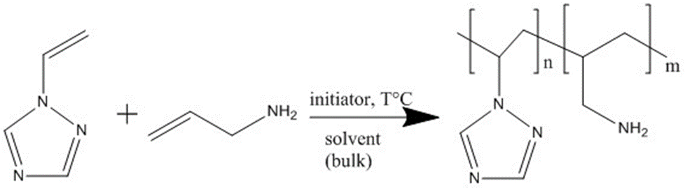

The obtained copolymers with yields up to 76% are white and yellowish powders, readily soluble in water, DMF, DMSO, DMAA. The structure and composition of the copolymers obtained were established by elemental analysis, IR and NMR spectroscopy. The maximum content of allyamine units in the copolymers, depending on the reaction conditions, reaches 18 mol. %.
The obtained hydrophilic copolymers are promising in the development of new non-toxic biologically active materials with antimicrobial, fungicidal, antitumoric, and other activity, as well as systems of directed delivery of contrasting and medicinal products.

Oxidative addition of unsaturated Triflamide substances and their interaction with each other
A.S.Ganin
A.E. Favorsky Irkutsk Institute of Chemistry of Siberian branch of Russian academy of science
(IIC SB RAS)
e-mail: noxes1293@mail.ru

The chemistry of sulfonamides is actively investigated for many years. Every year new substances, containing the sulfonamidny fragments, are synthesised. An interest to them is explained first of all by the fact that many compounds containing these groups possess a wide range of physiological activity and are a basis for the production of many substances, such as: antibiotics, insulin - producing compounds, disinfecting substances, fungicides, insecticides and herbicides. Sulfonamides, containing functional groups on the basis of fluorine at a sulphur atom are quite interesting because such groups are one of the most strong electroacceptors. This leads to the fact that these sulfonamides and their derivatives have high NH acidity, and because of this one can form both inner- and intermolecular bonds. It is also possible to tell that these compounds are of special interest for chemists due to the non-standard chemical behaviour, in comparison with their non-fluorinated analogues. The simplest representative of sulfonamides containing the perftoralkilny derivatives is trifluorosulfonamide (triflamide). Earlier, it was studied how triflamide behaves in a case with usual alkenes and dienes. My work is a continuation of researches of accession of a triflamid to unsaturated substrata under oxidising conditions. Furthermore, unsaturated and high-unsaturated compounds of a triflamide are used as substrata, which allow to expand significantly synthetic and theoretical chemistry of derivative triflats.
Another fascinating field of the triflamide chemistry is the reactions of oxidative triflamidation of alkenes and dienes, leading in many cases to the products different from those obtained with arenesulfonamides. It is reasonable to assume that the study of the reactions combining these two field, that is, the reactions of oxidative triflamidation of unsaturated triflamide derivatives, will lead to new unusual structures and specific patterns of reactivity. With this in mind, we investigated the reactions of triflamide 1 with N-allyltriflamide TfNHCH₂CH=CH₂ 2 and N,N-diallyltriflamide TfN(CH₂CH=CH₂)₂ 3 under oxidative conditions in the system (t-BuOCl + NaI).
The reaction of triflamide 1 with N-allyltriflamide 2 at –30°C affords the single product in quantitative yield identified as N,N',N''-propane-1,2,3-triyltris(triflamide) 3 (Figure 1).
Figure 1. Oxidative addition of triflamide 1 to N-allyltriflamide 2.
The structure of product 3 was proved by ¹H, ¹³C, ¹⁹F NMR and IR spectroscopy and elemental analysis.
Depending on the same reaction conditions, N,N-diallyltriflamide 4 gives a whole bunch of both linear and cyclic products in comparable amounts. (Figure 2).
Figure 2. Oxidative addition/cycloaddition of triflamide 1 to N,N-diallyltriflamide 2.
With equimolar ratio of the reagents at –10°С, the reaction mixture contains monoadduct 5, 3,7-diiodo-1,5-bis[(trifluoromethyl)sulfonyl]-1,5-diazocane 7 and 3,7,9-tris[(trifluoromethyl)sulfonyl]-3,7,9-triazabicyclo[3.3.1]nonane 8, along with a small amount of unreacted diene 4. Increasing the ratio of 4 to 1 to 1:2 and carrying out the reaction at –30°С results in full conversion of the reagents and formation of diadduct 6, apart from products 5, 7, 8. All the reaction products were isolated as individual compounds by column chromatography and their structure was determined by ¹H, ¹³C, ¹⁹F NMR spectroscopy and, for compounds 7 and 8, also by X-ray analysis respectively.
One-pot assembling of 1,5-diazocane and 3,7,9-triazabicyclo[3.3.1]nonane scaffolds shown in Figure 2 is of interest because the presence of 1,5-diazocane motif in oxidative polyamine metabolites was shown to be critical for inhibiting activity and suppressing cytotoxicity. The known methods of synthesis of 1,5-diazacyclooctanes suffer from costly reagents or long-term processes (up to nine days). The work presented shows the first one-pot synthesis of 3,7-diiodo-1,5-bis[(trifluoromethyl)sulfonyl]-1,5-diazocane capable of further functionalization at positions 3 and 7.
As to 3,7,9-triazabicyclo[3.3.1]nonane derivatives, their synthesis is based on the cyclization of compounds having the 2,4-bis(chloromethyl)piperidine moiety under the action of amines.¹⁰
The mechanism of oxidative triflamidation of compound 2 is similar to that proposed earlier and includes N-iodotriflamide, as the key intermediate reagent.
The mechanism of formation of the bicyclic product 8 depends on the fate of diadduct 6. Route a suggests its cyclization to the intermediate N,N'-{[1,4-bis(trifluoromethylsulfonyl)piperazine-2,6-diyl]dimethanediyl}bis(triflamide), that finally gives bicycle 8 by elimination of the triflamide molecule. An alternative route b is hardly possible since the two iodine atoms in the 8-membered cycle 7 being in the equatorial positions of the chair,chair-conformation of the 3,7-diiodo-1,5-bis[(trifluoromethyl)sulfonyl]-1,5-diazocane 7 molecule are too far from each other. Indeed, special experiment showed that compound 7 taken separately was not converted to bicycle 8 under the reaction conditions, suggesting an opposite mechanism b.
In conclusion, i can say, although there was no spectroscopic indication of formation of within the reaction mixture, the aforementioned different composition of the products of iodotriflamidation at different temperatures may be suggestive of the predominance of route a at higher temperature, when diadduct 6 is faster consumed to give bicycle 8 via intermediate. At a lower temperature of –30°C, the transformation via route a is retarded and diadduct 6 remains in the reaction mixture from which it could be (and was) isolated

Section 4. Geosciences, Solar Sciences and Hydrosciences: New Frontiers

3d-polyelement geochemical models in the solution of the problems of geological studies of the earth interior

A. N. Kosterev
A.P. Vinogradov Institute of Geochemistry Siberian branch of Russian academy of science (IGC SB RAS)
e-mail: ak.auken@gmail.com
A. M. Fedorov
A.P. Vinogradov Institute of Geochemistry Siberian branch of Russian academy of science (IGC SB RAS)
e-mail: sashaf@igc.irk.ru

High-purity quartz is a strategic raw material. Quartz is widely used in all branches of industrial production, which determines the level of development of high technologies (aviation, space, electrical engineering, radio electronics, semiconductor production, medicine, etc.). In recent years, the consumption of high-quality quartz raw materials by the world and the domestic industries increased tenfold. The shortage of quartz concentrate in Russia was compensated by imports, but due to the current foreign policy situation, the government pays great attention to the exploration and development of new quartz deposits. The interest in various manifestations of high-purity quartz raw materials is increasing, as one of the highest-quality materials - granular and transparent veined quartz. In Eastern Siberia, the most promising regions are the Irkutsk region and the Republic of Buryatia (East Sayan) [5, 6].
On the example of deposits of quartz raw materials Bural-Sardyk we develope an integrated estimation methodology of geological and geochemical data using three-dimensional modeling of geological and geochemical conditions. These conditions are based on the calculation of complex geochemical indicators, as well as the photogrammetric air drone-based survey of the terrain. The technology of photogrammetric survey makes it possible to construct a high-precision model of relief for obtaining a more detailed three-dimensional model that will allow estimating field reserves with high accuracy. The use of air drones for photogrammetric survey increases its efficiency due to the cost of the survey itself, and also makes it more mobile.
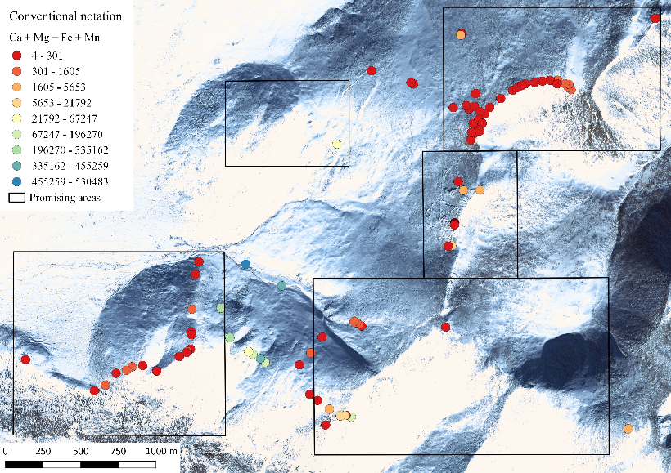
The research method assumes the selection and analytical studies of rock material samples during reconnaissance geological routes and surveys on a regular grid, as well as photogrammetric survey. At the same time, GIS technologies are used to collect, systematize and analyze the data received. Earlier, to study the deposits of quartz raw materials of the Eastern Sayan a spatial database "Superquartzites" and a program for calculating complex indicators ModuLi were developed based on the PostgreSQL/PostGIS and QGIS databases [2]. Since the results of chemical analysis of rocks are represented by a large set of chemical element concentrations which are difficult to visually analyze within the framework of a layered model, an original geoinformation approach based on the use of integrated geochemical indicators in geoinformation mapping was used to accelerate the process of visual analysis of geological and geochemical information [3], that generalize several indicators into one highly informative layer that explicitly reflects some property of the geological environment. For example, the total content of calcium, magnesium, iron and manganese, that indicates a quartz raw material, that in the future can easily be separated from impurity elements with further enrichment (Figure 3). With the help of these criteria, it is possible to identify promising areas of quartz raw materials.
Based on the computed data of complex indicators and the processed photogrammetric survey, a three-dimensional geochemical model is constructed that gives an idea of the structure and occurrence of elements in the study area. According to this model, it is possible to estimate the reserves of useful components within the study area, as well as to allocate more promising areas for further work.
Fig. 3. An example of calculating the sum of "Ca + Mg + Fe + Mn"

References
- Костерев А. Н., Федоров А. М. Совершенствование геоинформационной системы для обеспечения поисково-оценочных работ на кварцевое сырье // Вопросы естествознания. - 2015. - №2 (6). - с. 93-97
- Паршин А.В., Демина О.И. Интегральные геохимические индикаторы в основе математико-картографического обеспечения экспертных геохимических географических информационных систем // Проблемы недропользования. - 2014. - № 2. - С. 53-59
- Паршин А.В., Спиридонов А.М. Методические и технические решения геолого-геохимических ГИС для обеспечения комплексных научных исследований золоторудных объектов//Геология и минерально-сырьевые ресурсы Сибири. - 2014. - № 3с-2. - С. 72-76
- Просекин С.Н., Блинов А.В., Костерев А.Н., Шестаков С.А. Моделирование рельефа Приольхонья на основе глобальных цифровых моделей высот с оценкой их геометрической точности // Вопросы естествознания. - 2015. - №2 (6). - с. 104-111
- Федоров А.М. / Геохимия и условия образования особо чистых кварцитов на примере проявлений Восточного Саяна // автореферат дисс. к.г.-м.н. Иркутск, ИГХ СО РАН. - 2012г. – 22 с.
- Федоров А.М., Спиридонов А.М., Будяк А.Е., Сокольникова Ю.В., Куликова З.И. Условия формирования месторождения сверхчистых кварцитов Бурал-Сарьдаг (Восточный Саян) // Известия Сибирского Отделения Секции Наук О Земле Российской Академии Естественных Наук. - 2011 – №1 – Т 38 – С. 94-104

Architecture of information systems and data generalization methods for the development of a thematic geoportal for geochemical tasks
A.О. Mikhalyov
A.P. Vinogradov Institute of Geochemistry Siberian branch of Russian academy of science (IGC SB RAS)
e-mail: alexeycomikhalev@gmail.com
A.V. Parshin
A.P. Vinogradov Institute of Geochemistry Siberian branch of Russian academy of science (IGC SB RAS)
e-mail: sarhin@geo.istu.edu

The current functioning level of scientific organizations requires the development of new means of scientific activity which popularize and inform the public about the results of research, and provide information to specialists in the most convenient form of perception. These tasks can be successfully solved using information systems with Internet interfaces. One of the most popular cartographic systems are resources of environmental and geochemical content, since environmental monitoring data is maybe of interest to different specialists, local authorities as well as ordinary citizens. This is combined with the possibility to post information about scientific work the organization has done, which may not be available to specialists concerned. The best way to systematize and present such materials, usually expressed in cartographic form, is to use geoinformation systems (GIS) and geoportals, while archival materials of scientific institutions often require adaptation to new technologies of storing and processing of spatial information.
The pace of implementation of information and cartographic systems into practice is significantly constrained by two interrelated problems. The first is the difficulty of presenting a large set of heterogeneous information both in spatial and thematic relation in the form of a relatively small set of highly informative maps that are understandable to a wide range of ordinary users. For example, to evaluate the quality of the environment of unique geosystems, state environmental quality standards are inadequate, according to them it would be possible to classify information on the quality of the environment into good, acceptable and bad. Since such geoportal is a living system constantly supplemented with new data, it requires to develop automated methods of generalization and polyelement data visualization without losses of informativity and taking into account the calculated local or regional background. The second fundamental problem is related to the fact that it is impractical and even impossible to present all the primary information on the Internet platform for obvious reasons, because not every scientist wants the result of his many years work to be made publicly available since anyone can download it without the author’s permission. This requires the development of a metainformation structure indicating author’s contacts, etc. In order to generate interest for contacting authors, the information and cartographic materials (presented without revealing the data) should provide a complete picture of their quality and informativity [6].
In this paper we consider the solution of these problems by developing a web-based GIS and creating a web resource that will present the results of large-scale geochemical studies of scientists from the Institute of Geochemistry of Irkutsk from the 80’s and 90’s to the present day in the Baikal region and the Republic of Buryatia [1],[5],[6]. Within the framework of the research a large amount of data about chemical content of a number of elements was collected in various components of geosystems. It makes possible to create an informational environment that effectively promotes modern research.
Archived work materials of the last century were collected without GPS-binding, the development level of information network technologies in those years did not allow to present the results of work in a convenient and informative form to users. GIS-systems and technologies were just emerging. In this connection, the problem of systematization and correct spatial determination of points was being solved. In the existing tables local coordinates were initially assigned to each sampling point, which were subsequently recalculated into coordinates in the WGS-84 projection (Figure 1).
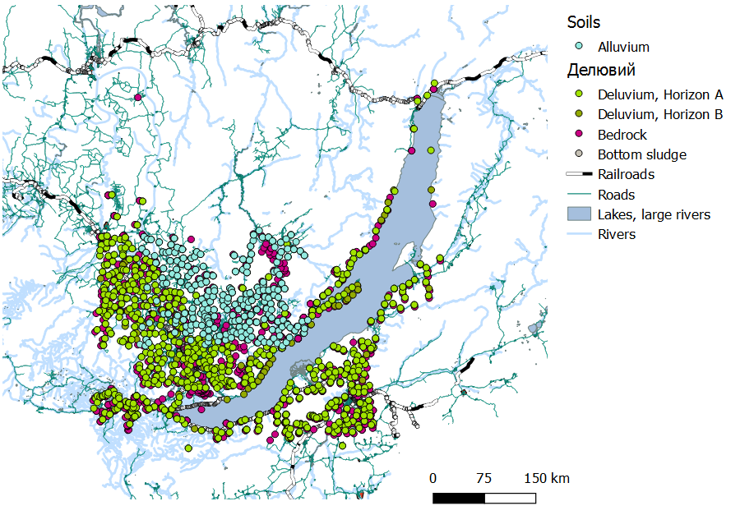
Figure 1. Map of some works of the 90’s performed by the specialists of the Institute of Geochemistry SB RAS.

Since the creation of a geoportal requires the storage of all geochemical data on the database server, and a separate map-based web server that draws and represents layers in the web environment, the first major step in the work was a creation of a spatial database. Archived materials were collected into text files csv and then re-exported to the shp geometry file format for more convenient geoinformational processing. In future it is planned to translate the data array into the PostgreSQL / PostGIS database format to realize the possibility of dynamic update and more efficient interaction with the geoportal environment.
The created database includes the following thematic blocks: alluvium, deluvium of horizons A and B, bottom sludge, bedrock, microelements and macroelements in water. Based on the available data set, the method of geoinformational analysis has been tested, which makes it possible to divide the territory into areas with a similar geochemical setting and later to identify local anomalies of environmental quality within each individual site. This method is based on multidimensional factorial geoinformational analysis.
For each element in each sampling point the concentration coefficient Kk was considered. Kk is the ratio of the content of a chemical element in the natural environment to its background content. Initially, as the background content, the value of the median was taken across the database thematic block. Factor analysis was used by the principal component method in its GIS variant [4], previously time-tested for solving both ecological and geological exploration problems [3], [7]. Its main point consists in the repeated calculation and mapping of the principal components, which allows us to divide the entire territory of the Baikal region into areas with a similar geochemical setting and to analyze these areas separately in subsequent iterations of the calculation. As an example, the first principal component largely reflects anomaly of Rb, Cs and F (Figure 2). Then the analysis is carried out for each region characterized by similar values of the principal component, which allows us to identify the main characteristics of the geochemical setting within it. Based on the results of two iterations of factor analysis and its interpretation, it’s possible to identify a number of informative associations of elements that mark certain types of impacts or phenomena on an area. The cartographic representation of such zones on one map is an integrated ecological and geochemical characteristic of the environment; it can be represented on a geoportal and does not disclose the quantitative characteristics of the initial data without violating confidentiality.
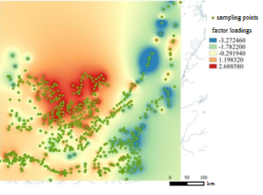
Figure 2. Cartographic representation of the first principal component and corresponding factor loadings.

The cartographic server should be implemented on the Geonode open source platform, based on the Geoserver. The resulting “integrated maps” should be provided to users as layers, while visually invisible layers are implemented with metainformation about the data available for each region. A person concerned will always be able to find information about all scientific works carried out by the scientific organization for the area in question and he will also see the visual presentation of the results, and if necessary, contact the authors.
At the moment calculations and their interpretation have not been completed yet but the results obtained make it possible to consider the task of creating several “integrated maps” achievable using the described method. Thus, in the near future it is planned to create a web-cartographic resource that reflects results of the research activities of scientists from the Irkutsk Institute of Geochemistry in the form of easily interpretable maps on GIS-technology, similar to the already available web-mapping resources [2].

References
- Гребенщикова В.И., Лустенберг Э.Е., Китаев Н.А., Ломоносов И.С. Геохимия окружающей среды Прибайкалья // Новосибирск: ГЕО, 2008, 234 с.
- Михалев А.О., Байгускарова А.Д., Кавандина Е.В., Матыцин В.В. Принципы и ГИС-технологии организации системы радиоэкологических исследований территории г. Иркутска в рамках научно-исследовательских работ студентов // Современные наукоемкие технологии. 2014. № 7-2. С. 38-40.
- Паршин А.В., Демина О.И. Интегральные геохимические индикаторы в основе математико-картографического обеспечения экспертных геохимических географических информационных систем // Проблемы недропользования. 2014. № 2. С. 53-59.
- Паршин А.В., Спиридонов А.М. Методические и технические решения геолого-геохимических ГИС для обеспечения комплексных научных исследований золоторудных объектов // Геология и минерально-сырьевые ресурсы Сибири, 2014, № 3-2, с. 65-69.
- Паршин А.В., Шестаков С.А., Чудненко К.В., Савельев Е.П. Критерии оценки геоэкологического состояния вод оз. Байкал // Вода: химия и экология. 2013. № 9 (63). С. 24-31.
- Филимонова Л.М., Паршин А.В., Бычинский В.А. Оценка загрязнения атмосферы в районе алюминиевого производства методом геохимической съемки снежного покрова // Метеорология и гидрология. 2015. № 10. С. 75-84.
- Auzina L.I., Parshin A.V. 2016 System – integrated GIS-based approach to estimating hydrogeological conditions of oil-and-gas fields in Eastern Siberia // IOP Conference Series: Earth and Environmental Science vol. 5.

Gender Features of the Crimes Related to Violence in Family
T.G. Bukhaeva,
M.N. Zvereva
Irkutsk Institute of Geography, Siberian Branch of Russian Academy of Sciences
(IG SB RAS)
e-mail: vicious.sunny@gmail.com
zvereva.mari@bk.ru

Gender stereotypes are regulated at the deep mental level of social consciousness based on the past experience and transmitted from generation to generation. Social models of gender identification and proper behavior as a representative of the gender role have long been formed taking into account various aspects, such as historical, social, economic, cultural, religious and political. Accepting gender as a certain standard of male or female behavior set by the society; we consider the related features of the behavior of men and women in the family as in a social institution.
Every year throughout the world there has been a steady increase in crimes related to encroachment on human life. Of great significance is the problem of violence in family, as well as issues related to violence counteracting. According to data, violence in family is systematic and revealed in every second or fourth family.
The international community has placed the problem of family violence on a par with organized crime, drugs and terrorism. This phenomenon not only undermines the fundamentals of the education of the legal culture in general, but also affects the demographic situation in the world. It represents a real and potential danger not only for the social health of the family, but also for the younger generation and society as a whole.
The government recognizes the scale of family violence and urgency of legal responses. However, it prefers not to interfere in the family sphere, causing the difficulty in establishing limits of private and public interests of the family institution.
Trying to assess the full scale of the crimes related to violence in the family, one should not rely on official statistics, since most of the crimes are latent in nature, distorting the statistical picture of crimes against the family. As a rule, latent crime exceeds registered crimes 3-4 times.
One of the reasons not to contact the police is the desire to preserve the prestige of the family. Another reason is fear, fear of the offender, and beliefs that no law can protect victims.. Therefore, only one of ten cases of beatings is reported to the police. Also victims extremely rarely apply to the authorities for the actions of elder brothers and sisters, since the parents of victims and offenders prefer to deal with their children independently without law enforcement agencies. Besides, crimes related to sexual abuse are not advertised by 90 percent victims at all. In addition, it is worth noting that there is considerable number of crimes, where husbands are victims, who also prefer keeping silence about the relationship in their family.
Also it is necessary to take into account gender when considering the problem of family violence. Currently, the world community speaks a lot about the need for a "gender approach", the need to consider violence from all sides. However, for a long time in Russian and foreign science, the issues on personality and gender studies were not given proper attention. Gender studies in Russia have been extremely rare. It is evidenced by the lack of national literature on gender, and issues related to the sexual characteristics of the individual are unexplored.
It should be noted that the turning point in the formation of gender features in Russia was a large political event of the 20th century - the Great October Social Revolution in 1917, which was able to change gender stereotypes in the formation of the consciousness of Soviet people.
The traditional patriarchy dominated in pre-revolutionary Russia, so when changing to another form of power, women began to defend actively their rights, seeking to fill all spheres of life. Since women got equal rights with men, women were more and more involved in industrial production, which led to the family way of life, where both parents were breadwinners, earners. Undoubtedly, this way of life contributed to some transformation, which also played an important role in the formation of the family.
Sociologists, economists, lawyers and other representatives of the sciences made a conclusion that socio-psychological phenomena, such as family unhappiness, the level of education, the level of general culture and legal awareness are the preconditions for family violence.
So, the probability of family violence will be higher in the family where three or even four generations are forced to live on a small living space. Sharing the same rooms by adults and children causes teenagers to awaken prematurely interest in sexual life, which causes moral damage to society as a whole.
The well-being of a family influences the mental state of all members of the family. The lack of material goods is an irritating factor. Other problems related to social stress in the family are disagreements in children upbringing, sex, pregnancy, childlessness, financial difficulties, unemployment, discrepancy between desires and opportunities.
The factor of territoriality must be considered when studying crimes related to family violence, their causes and conditions. Each territorial unit is characterized by its own set of criminogenic factors. It should be noted that the Irkutsk region attracts a lot of immigrants, because of economic characteristics of the East Siberian region. In addition, it should be remembered that the Irkutsk region used to be an exile place, which also influenced the criminal component of the region. Territorial studies will reveal the ways and methods of struggling against such an antisocial phenomenon as family violence. It can solve issues related to the modeling and prediction of crime on the regional level.
Considering the influence of urban and rural agglomeration on family violence, it is worth paying attention to the fact that violence among relatives in district centers and villages is more extensive than in large cities.
The increase in the number of criminal attacks in rural areas is due to the low level of culture of the population, low wages, the lack of sufficient jobs and cultural and recreational centers, the lack of social and psychological centers, and the lack of transport.
The problem of family violence is one of the important problem of society and the institution of family. It is the institution of family that is a main place of traditions and culture.
In most countries there are special laws related to the fight against family violence. In Russia, there are few laws against family violence if at all. First, in Russia there is no practice of protection order, that is, a judicial act prohibiting the offender from entering any contact with the victim. This protection order can establish the distance to which the offender must not approach the victim. The offender can be sent to prison for violating the act. Crisis and rehabilitation centers are poorly developed in Russia. These centers have to provide victims with psychological and legal assistance. In Russia there are no social institutions, where victims of family violence can spend night and get food free.
To prevent family violence, quite a number of problems need to be considered and resolved. The prevention of offenses is quite possible. But one can hope for effective results only when there is skillful interaction of all participants in the struggle against crimes in families.

Optical spectroscopy of molybdates with composition Ln₂Zr₃(MoO₄)₉ (Ln: Nd, Eu, Tb).
D. Sofich;
A.P. Vinogradov Institute of Geochemistry Siberian branch of Russian academy of science (IGC SB RAS)
e-mail: sofich-dmitriy@mail.ru
R. Shendrik
A.P. Vinogradov Institute of Geochemistry Siberian branch of Russian academy of science (IGC SB RAS)
Introduction
Double molybdates containing rare-earth ions are promising phosphors and active laser medium.
The study of their optical and luminescent properties helps to expand the range of problems that can be solved by the use of new materials.
Methodology
Double molybdates with the composition Ln₂Zr₃(MoO₄)₉ (Ln: Nd, Eu, Tb) were investigated.
Nd₂O₃, Eu₂O₃, Tb₄O₇ and MoO₃, ZrO₂ obtained by calcination of ZrOCl₂·8H₂O were used as initial reagents for the synthesis of double molybdates. The stepwise annealing of the stoichiometric amounts of the corresponding reagents with homogenization of the mixture was carried out every 50°C for 150 hours. The final synthesis temperature of molybdates with the composition Ln₂Zr₃(MoO₄)₉ (Ln: Nd, Eu, Tb) was 700°C [1].
The luminescence spectra were measured by excitation with a 150W xenon lamp through a MDR-2 monochromator equipped with a grating of 1200 lines/mm. The luminescence was recorded using a SDL-1 monochromator with a grating 600 lines/mm and a photomultiplier FEU-83 for the visible spectral region and 300 lines/mm and an FEU-106 for the near infrared.
The sample was spread on a LiF crystal-mount and placed in to vacuum cryostat.
To measure the decay of luminescence, a pulsed argon lamp and a digital oscilloscope were used, combined with the monochromators SDL-1 and MDR-2. The decay time of the most intense transitions at 298 K and 77 K was measured.
Optical spectroscopy
Two types of bands in the excitation and luminescence spectra of double molybdates with the rare-earth ion (REI) was obtained: broad bands with a peak of 290 nm are present in all spectra and refer to charge transfer from the 2p orbitales of the O²⁻ ion to free 4d states of Mo, followed by energy transfer to the rare-earth ion; thin lines refer to 4f-4f transitions in the REI [2].
Nd₂Zr₃(MoO₄)₉
The Nd₂Zr₃(MoO₄)₉ luminescence spectrum contained characteristic bands corresponding to the ⁴F_{3/2}-⁴I_{9/2} (900 nm) and ⁴F_{3/2}-⁴I_{11/2} (1064 nm) transitions (Fig. 1). The charge-transfer band has a low intensity with respect to 4f-4f transitions. The decay in all bands contains several exponentials. This may indicate the existence of centers with different environments of a rare-earth ion. The decay time for the ⁴F_{3/2}-⁴I_{11/2} transition was 22/40 and 15/40 μs (double processes) at 298 K and 77 K, respectively.
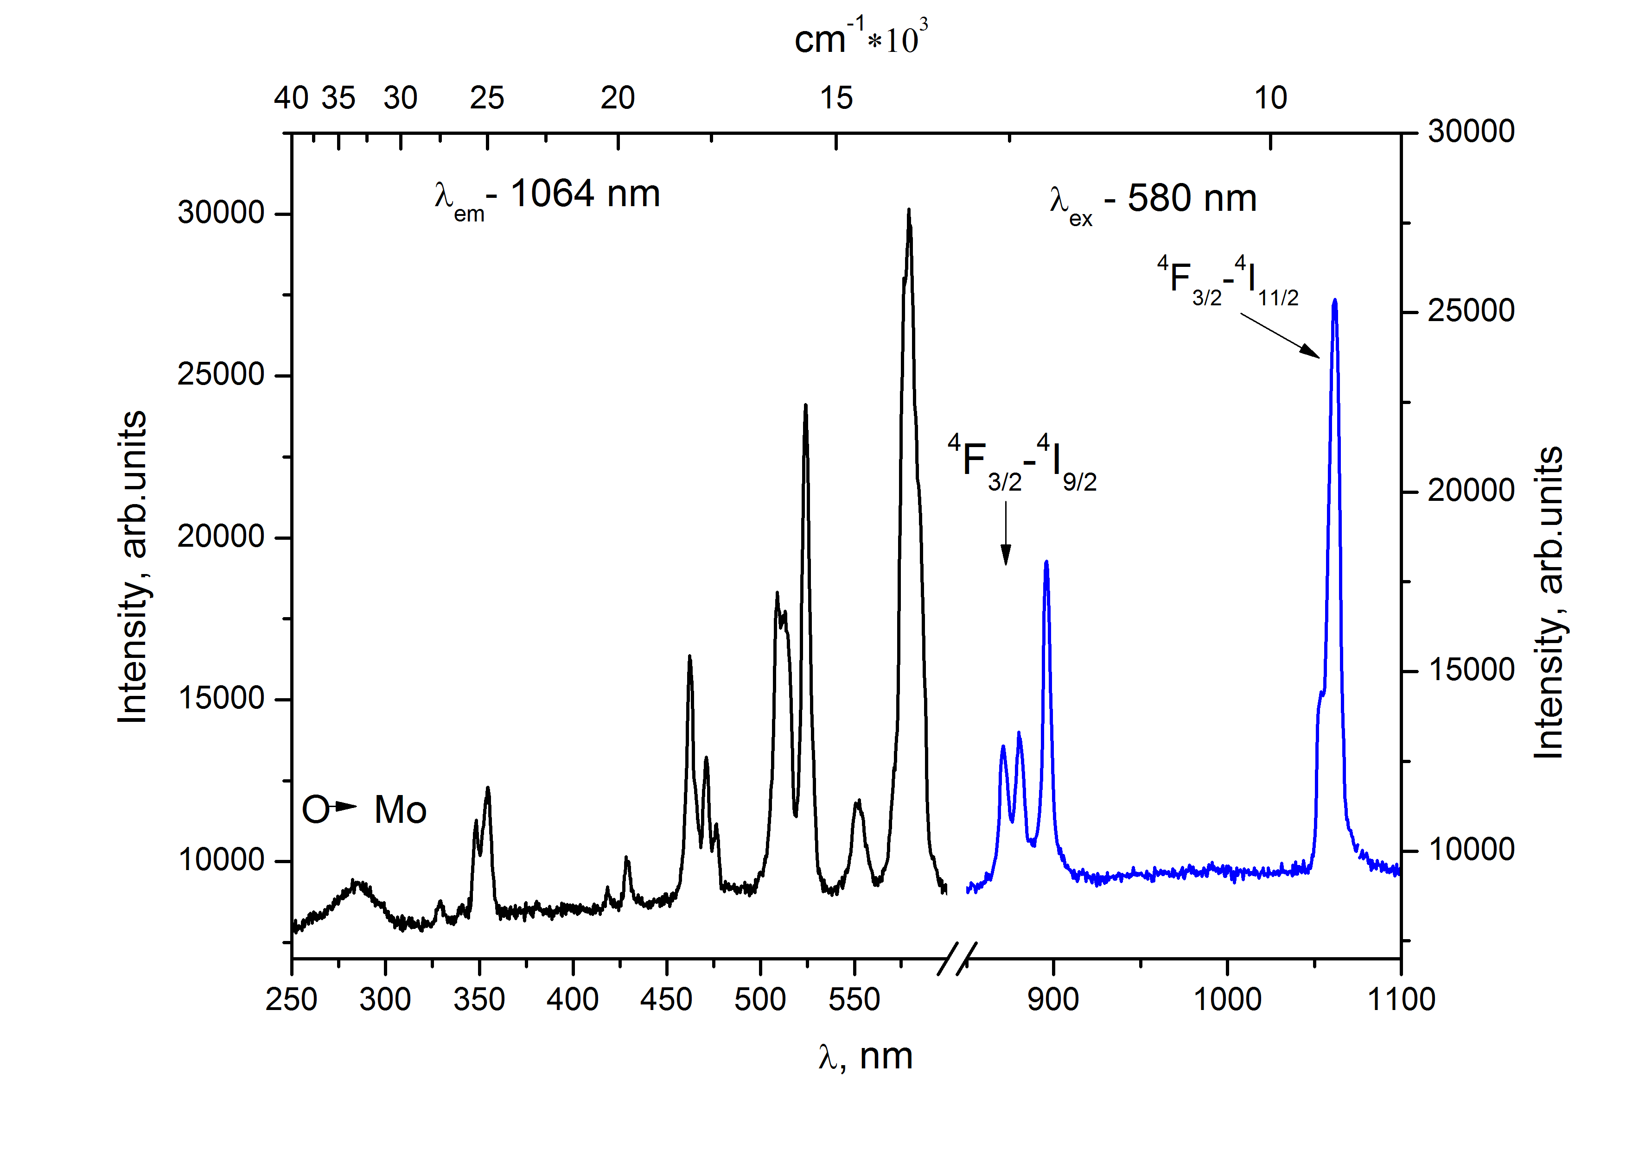
Fig. 1. Excitation and emission spectra of Nd₂Zr₃(MoO₄)₉.

Eu₂Zr₃(MoO₄)₉
Eu₂Zr₃(MoO₄)₉ has intense luminescence in the red region of the spectrum (Fig. 2(a)). The band corresponding to the dipole transition ⁵D₀-⁷F₂ (616 nm) saved its shape upon excitation to any band except ⁷F₀-⁵D₂ (464 nm). In this case, the band split at 77 K as shown in the figure 2(b).
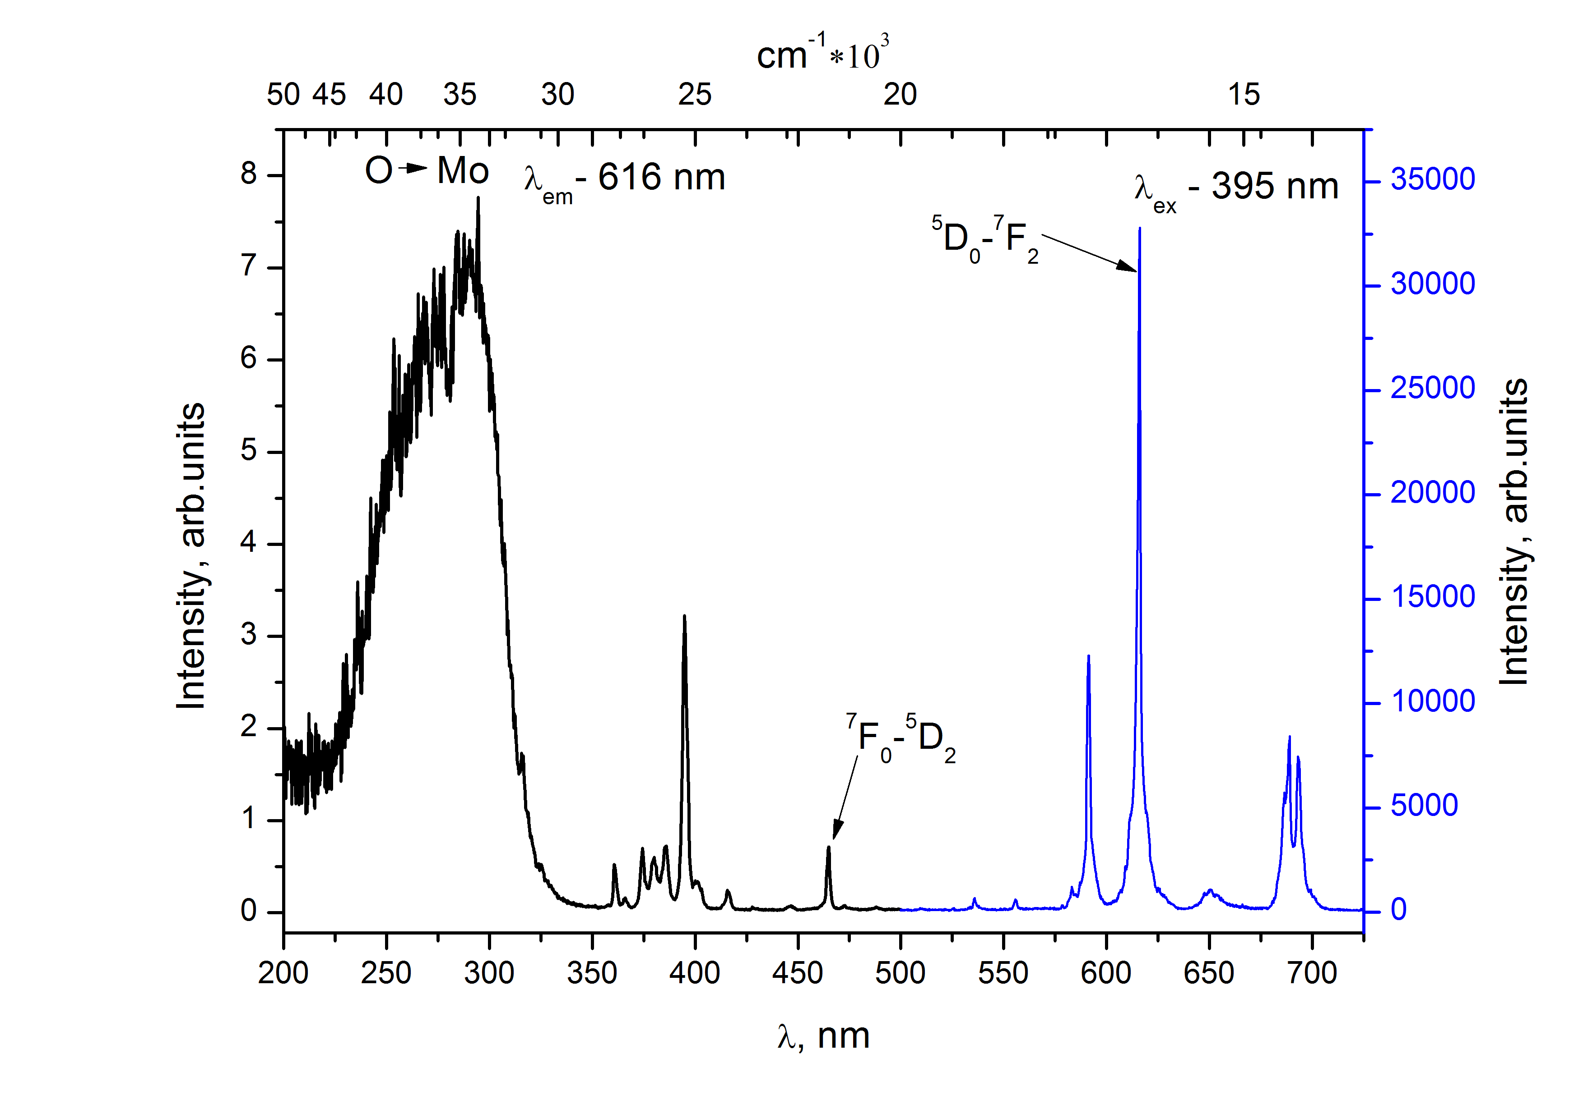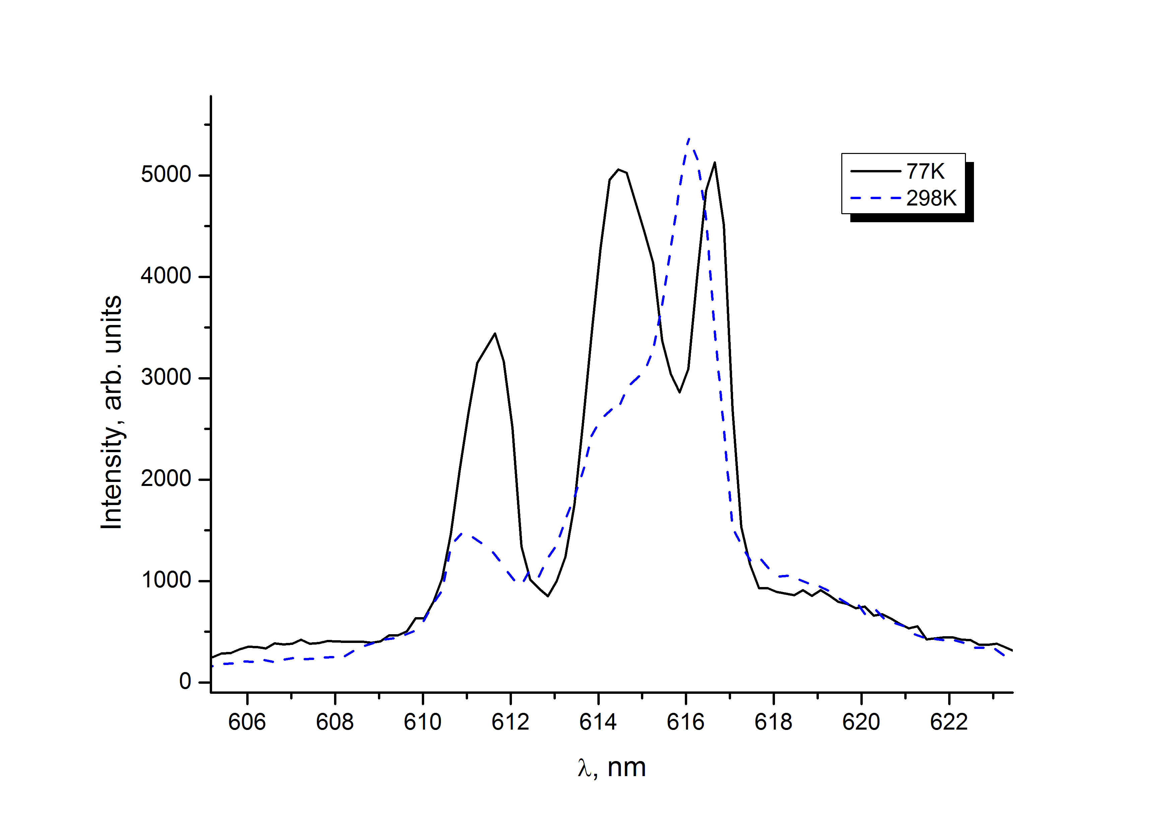
a) b)
Fig. 2. Excitation and emission spectra of Eu₂Zr₃(MoO₄)₉ (a); ⁵D₀-⁷F₂ band splitting (b).

Excitation in to other bands does not lead to such an effect. Decay time of the luminescence showed that in all transitions the luminescence decays according to the monoexponential law. An exception is the luminescence of 616 nm under excitation 464 nm at room temperature. In this case, two processes of 110 and 390 microseconds occur. Upon cooling, the decay again becomes exponential with a duration of 300 μs.
Tb₂Zr₃(MoO₄)₉
The Tb₂Zr₃(MoO₄)₉ spectrum contains 4f-4f transitions typical of Tb³⁺, as well as an intense charge transfer band (Fig. 3). The decay time in the most intense ⁵D₄-⁷F₅ (545 nm) band was 450 and 420 μs at 298 K and 77 K, respectively.
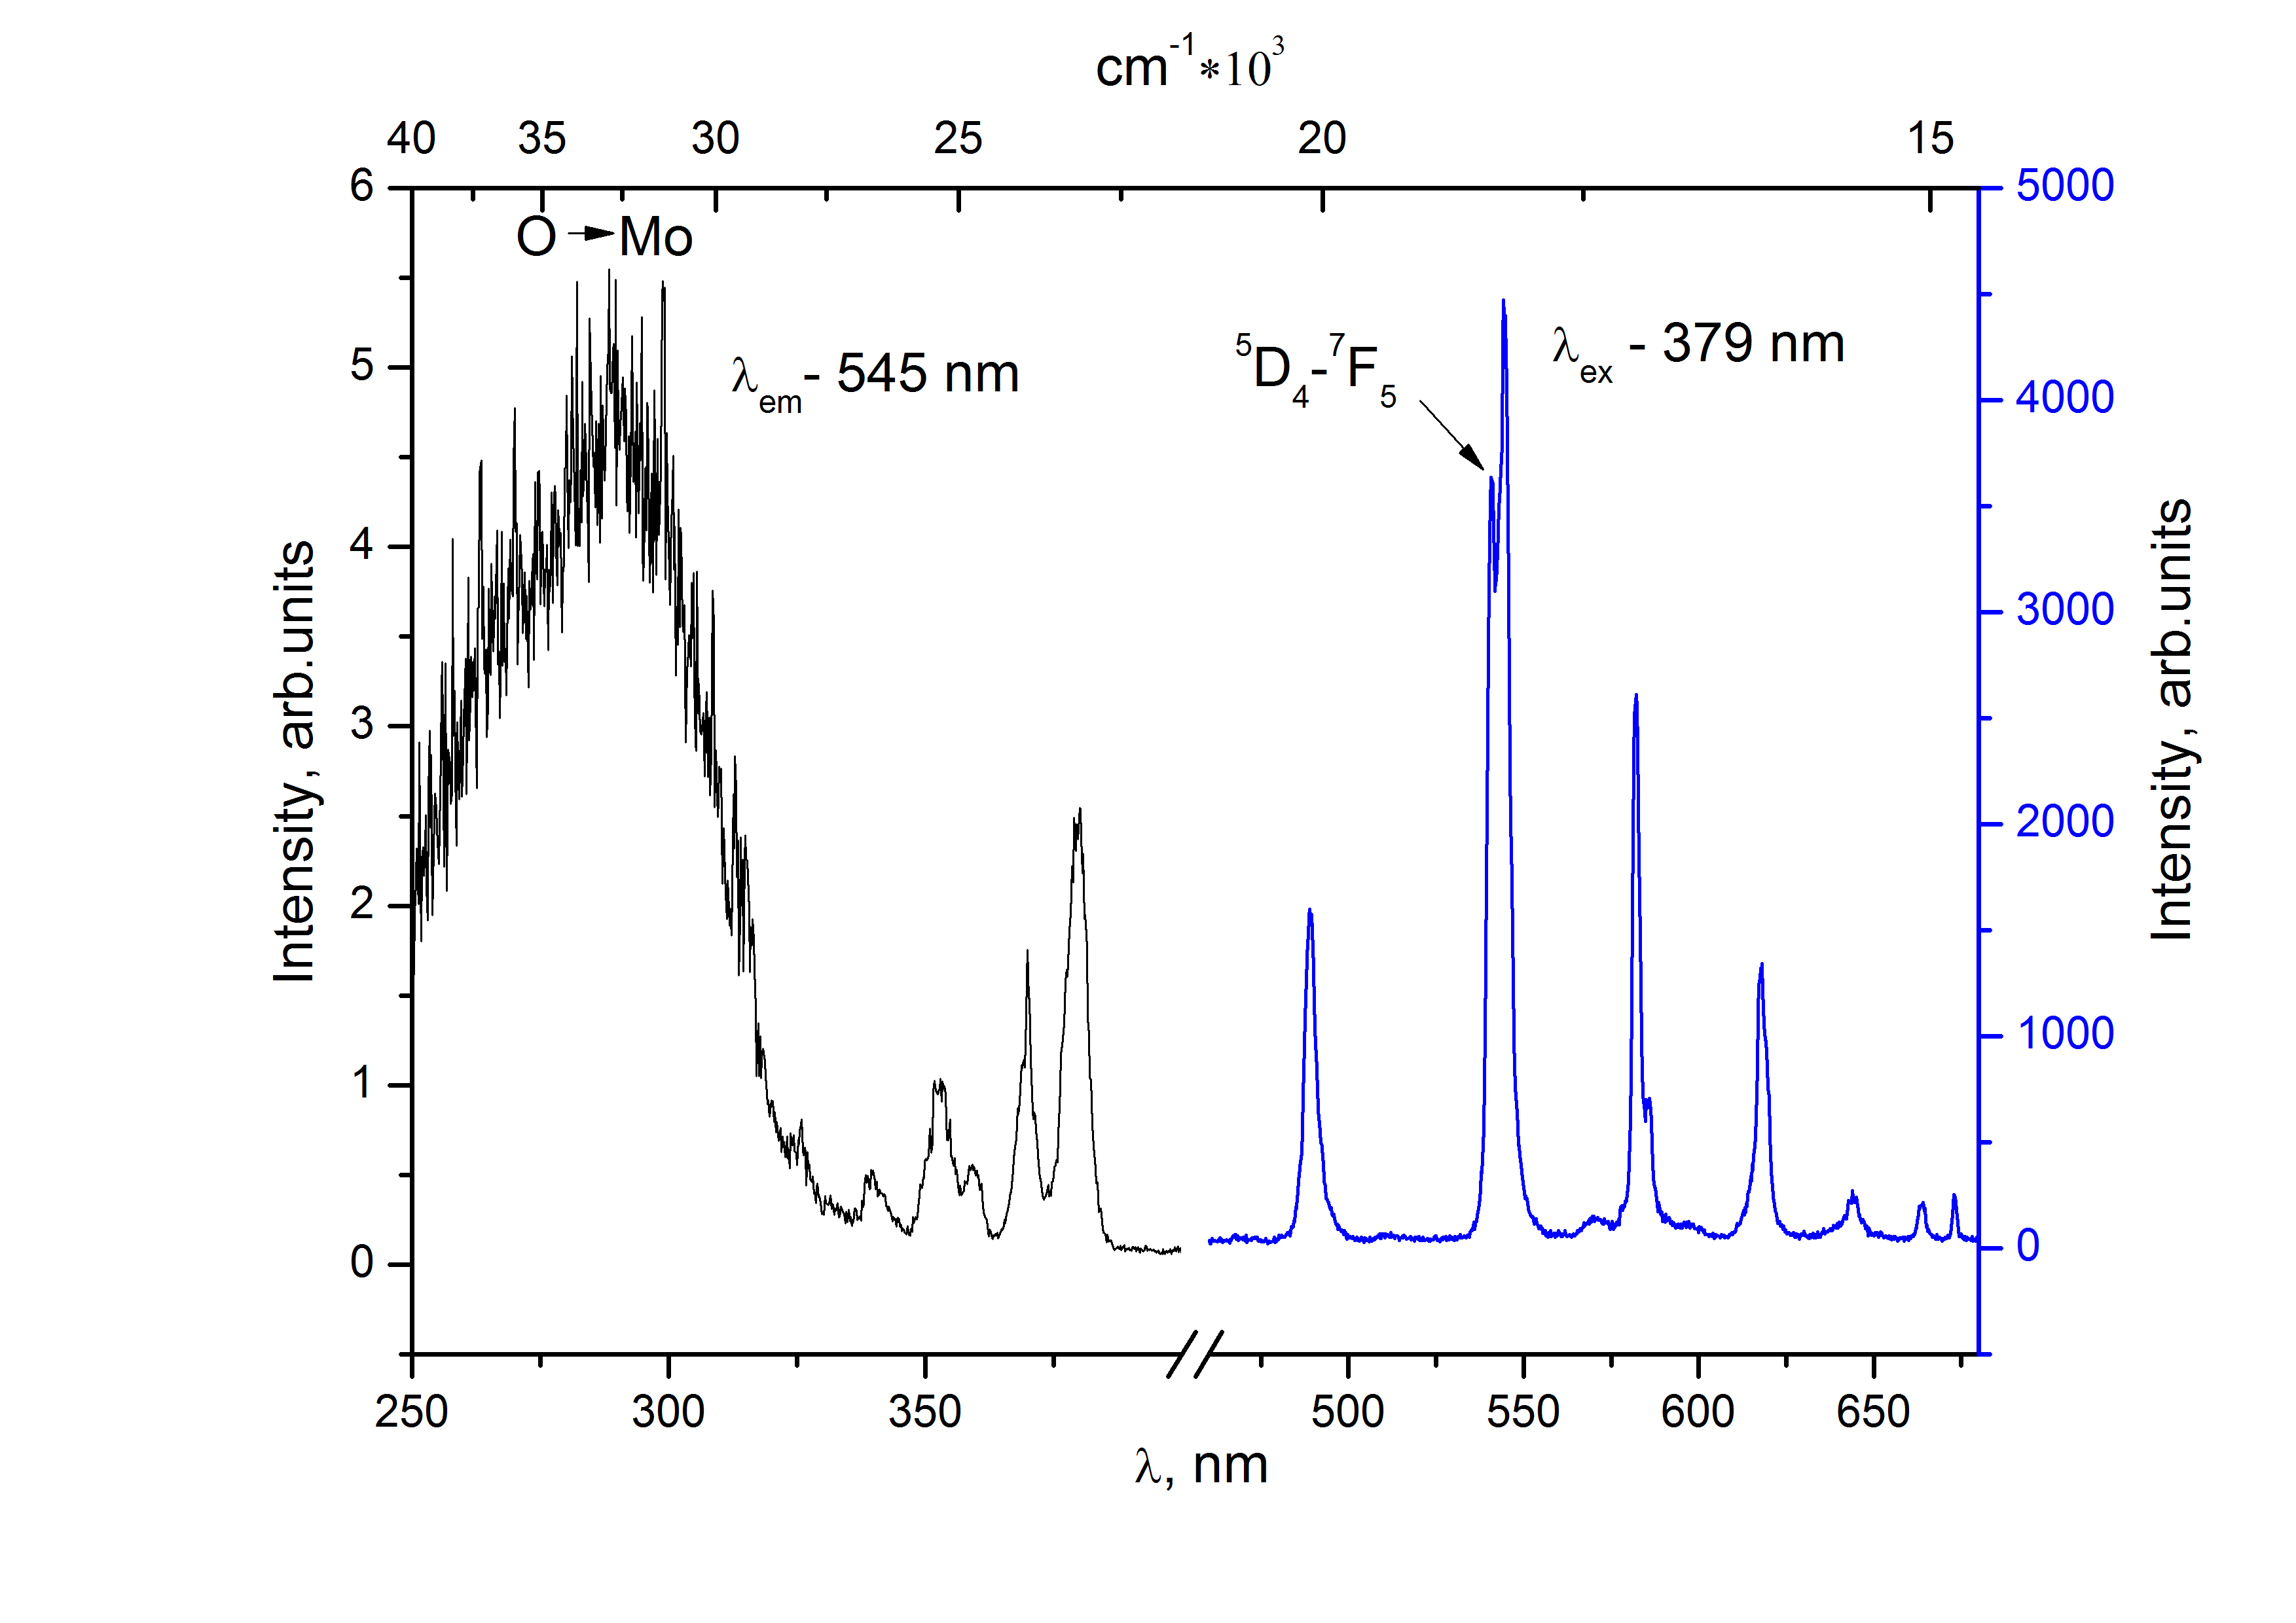
Fig. 3. Excitation and emission spectra of Tb₂Zr₃(MoO₄)₉.

Conclusion
The luminescence and excitation spectra of double molybdates containing rare-earth ions (Nd, Tb, Eu) were measured. In the molybdates under study, the rare-earth ions have a valence of 3+, which is confirmed by the position of the 4f-4f transition bands[3].
In all excitation spectra the broad band with charge transfer O → Mo was observed. The decay time constants of the luminescence of the brightest transitions were measured.
References
- S.G. Dorzhieva, Y. L. Tushinova, B. G. Bazarov. et al., Luminescence of Ln-Zr containing molybdates, Bull. Russ. Acad. Sci. Phys. 2015. V. 79. №2. P. 300-303.
- Ghosh, K. Sudarshan, R. Gupta, P.K. Pujari and R. Kadam, Dalton Trans. 2015. DOI:10.1039/C5DT03113C.
- P. Dorenbos, Electron binding energies and how it relates to activator luminescence and bonding in compounds, J. Lumin. 2016. V. 169. P. 381-386

Computational fluid dynamics
A.A. Ivanov
A.P. Vinogradov Institute of Geochemistry
Siberian Branch of Russian Academy of Science
(IGC SB RAS)

Computational fluid dynamics (CFD) is a branch of fluid mechanics that uses numerical analysis and data structures to solve and analyze problems that involve fluid flows. Computers are used to perform the calculations required to simulate the interaction of liquids and gases with surfaces defined by boundary conditions. With high-speed supercomputers, better solutions can be achieved. Ongoing research yields software that improves the accuracy and speed of complex simulation scenarios such as transonic or turbulent flows.
Methodology
In all of these approaches the same basic procedure is followed.
- During preprocessing
- The geometry and physical bounds of the problem can be defined using computer aided design (CAD). From there, data can be suitably processed (cleaned-up) and the fluid volume (or fluid domain) is extracted.
- The volume occupied by the fluid is divided into discrete cells (the mesh). The mesh may be uniform or non-uniform, structured or unstructured, consisting of a combination of hexahedral, tetrahedral, prismatic, pyramidal or polyhedral elements.
- The physical modeling is defined – for example, the equations of fluid motion + enthalpy + radiation + species conservation
- Boundary conditions are defined. This involves specifying the fluid behavior and properties at all bounding surfaces of the fluid domain. For transient problems, the initial conditions are also defined.
- The simulation is started and the equations are solved iteratively as steady-state or transient.
- Finally a postprocessor is used for the analysis and visualization of the resulting solution.
Discretization methods
The stability of the selected discretization is generally established numerically rather than analytically as with simple linear problems. Special care must also be taken to ensure that the discretization handles discontinuous solutions gracefully. The Euler equations and Navier–Stokes equations both admit shocks, and contact surfaces.
Some of the discretization methods being used are:
Finite volume method
In the finite volume method, the governing partial differential equations (typically the Navier-Stokes equations, the mass and energy conservation equations, and the turbulence equations) are recast in a conservative form, and then solved over discrete control volumes. This discretization guarantees the conservation of fluxes through a particular control volume.
Finite element method
The finite element method (FEM) is used in structural analysis of solids, but is also applicable to fluids.
Boundary element method
In the boundary element method, the boundary occupied by the fluid is divided into a surface mesh.

Software
There are many mathematical programs designed to perform calculations of the motion of liquids and gases, for example:
AcuSolve; ANSYS CFX; ANSYS Fluent; Autodesk Simulation CFD; Comsol Multiphysics
Autodesk CFD software provides fast, accurate, and flexible fluid flow and thermal simulation tools to help predict product performance, optimize designs, and validate product behavior before manufacturing—minimizing reliance on costly physical prototypes and helping you get innovative products to market faster. Easily explore and compare design alternatives and better understand the implications of design choices using an innovative Design Study Environment and automation tools. Autodesk CFD software supports direct data exchange with most CAD software tools including Autodesk® Inventor software, Autodesk Revit software, Pro/ENGINEER, and SolidWorks
It is distributed in a number of different core packages to cater to specific applications, such as mechanical event simulation and computational fluid dynamics.
Typical uses include bending, mechanical contact, thermal (conduction, convection, and radiation), fluid dynamics, and coupled or uncoupled multiphysics.

Geochemistry of Alkaline Picrobasalts of the Hentei range
V.V.Boroldoeva
A.Ya. Medvedev, Doctor of Geological and Mineralogical Sciences, Chief Researcher.
A.P. Vinogradov Institute of Geochemistry
Siberian branch of Russian academy of science
(IGC SB RAS)
e-mail: boroldoeva@mail.ru

Alkaline volcanism associated with riftogenic processes is widely developed in the folded frame of the Siberian Craton [2, 4]. The largest riphotogenic structure in Central Asia is the Baikal rift zone [1, 3, 6]. Near the southwestern flank of the Baikal rift zone there is the South Baikal volcanic region (SBVR), which covers an area of 350x450 km. Several stages of magmatism from the Late Oligocene (34-24 Ma) to the Late Pleiocene-Pleistocene-Holocene (<3 Ma) are distinguished within the SBVR [8].
In addition, Cenozoic alkaline volcanics are widespread in the central part of the Southern Transbaikalia, although the scale of manifestation is much less than in the South Baikal volcanic region. Alkaline basaltoids with an age of 5.5 - 8 million years [7] have been known for a long time in the southern Transbaikalia on the Hentei Range. Here they occur in the form of small streams and coverlets in the headwaters of the rivers Chikoy, Chikokon and in the middle current of the Burkal River.
The greatest prevalence of young basalts in the middle reaches of the Burkal River and its right tributary of Harchevka. They lie in the form of an extended (up to 15 km) valley stream, which is divided into several fields with a square up to 6-7 km2 (Fig. 1). Relicts of this stream are also observed on the right bank of Harchevka in its middle current. Here they occur in the form of small individual fields with an area of no more than 0.5 km2 [5].
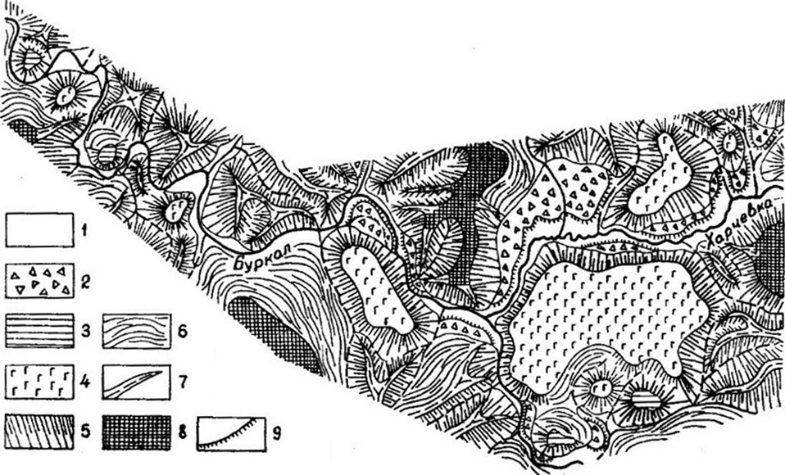
Figure 1. Geomorphological scheme of the valley of the river Burkal at the mouth of the Harchevka river: 1 - floodplain; 2 - valley pediments; 3 - high erosion terrace without basalt cover; 4 - the same, armored basalt; 5 - steep slopes; 6 - gentle slopes of the valley; 7 - narrow rocky ridges; 8 - plateau-shaped peaks; 9 - terrace-like ledges.
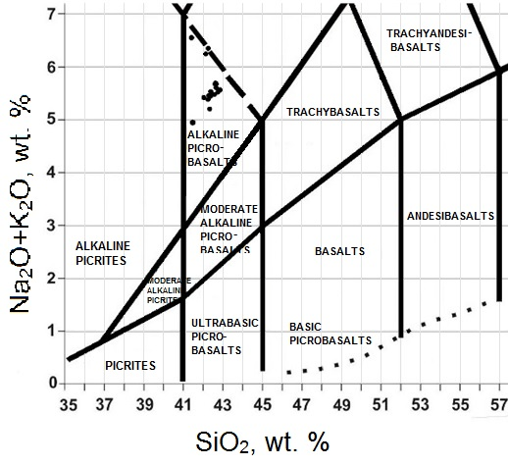
Figure 2. Classification diagram of SiO2 - (K2O + Na2O) (wt %) of alkaline picrobasalts of the Harchevka River
Black and dark grey, slightly porous basalts with sparse small phenocrysts of green and yellowish-green olivine up to 2 mm in size lie at the base of the basalt flow near the estuary of Harchevka. Plate-like separation is characteristic of this area. The thickness of this type of basalts is 20 m. Black, slightly porous basalts with numerous large (up to 1 cm) phenocrysts of green olivine and less often pyroxene are observed higher in the section. Oval secretions of dark translucent volcanic glass with a greenish thin rim due to the development of alkaline hornblende are noted. The thickness of the upper part of the flow reaches 40 m [5].
According to the point position of the composition of the rock group under study in the TAS diagram, the Harchevka volcanics are determined as alkaline picrobasalts. These rocks have low silicic acid content (41-42%). In addition, the explored alkaline picrobasalts have an increased content of TiO₂, MgO, P₂O₅, HFSE (Nb, Ta) and the corresponding ratios of indicator ratios of the rare earth elements (Ba / Nb = 5.8-6.9, Nb / Zr = 0.31-0, 34). The sufficiently high degree of rare earth elements fractionation for volcanics under research should relate to geochemical features (La/Yb = 29,3-39,3, Dy/Yb = 3,41-4,41).

Figure 3. Graph of the normalized chondrites distribution of REE in alkaline picrobasalts of the Harchevka River.

Figure 4. Multielement spectra for the alkaline picrobasalts of the Harchevka River normalized for primitive mantle.

The character of the distribution of elements in the volcanics under study is not significantly different from the middle composition of OIB. However, the volcanics have a more enriched composition, which is clearly manifested on the plot of the REE distribution and multielement spectra for the alkaline picrobasalts of the river Harchevka (Fig. 4 and 5). It follows that for these volcanics the higher degree of fractionation elements is established, than for OIB.
Because the volcanics under study have a more enriched composition, than the OIB, we can assume that most likely the Hentei range was formed as a result of the mantle plume influence on the lithosphere [9].

References
- Буслов М. М. Геодинамическая природа Байкальской рифтовой зоны и ее осадочного выполнения в мелкайнозойское время: эффект дальнего воздействия Монголо-Охотской и Индо-Европейской коллизий//Геология и геофизика, 2012, Т. 53, № 9, С.1245-1255.
- Воронцов А. А., Ярмолюк В. В. Северо-Монголо-Забайкальская полихронная рифтовая система (этапы формирования, магматизм, источники расплавов, геодинамика) //Литосфера, 2004, № 3, С. 17-32.
- Киселев А. И., Медведев М. Е., Головко Г. А. Вулканизм Байкальской рифтовой зоны и проблемы глубинного магмообразования. Новосибирск, Наука, 1979, 197 С.
- Коваленко В. И., Ярмолюк В. В., Богатиков О. А. Геодинамическое положение новейшего вулканизма Северной Евразии//Геотектоника, 2009, № 5, С. 3-24.
- Костяков Н.П., Краснов В.П., Уфимцев Г.Ф., Яновский В.М. Кайнозойские базальты юга Центрального Забайкалья // Известия Забайкальского филиала географического общества СССР, 1969, том 5, выпуск 1, с. 11-17.
- Логачев Н. А. История и геодинамика Байкальского рифта// Геология и геофизика, 2003, Т. 44, № 5, С. 391-406.
- Поляков А. И., Багдасарьянц Г. П. О возрасте молодых вулканов Восточной Сибири и закономерностях эволюции состава вулканитов // Геохимия, 1986, № 3, С. 311-317.
- Ярмолюк В. В., Иванов В. Г., Коваленко В. И., Покровский Б. Г. Магматизм и геодинамика Южно-Байкальской вулканической области (горячей точки мантии) по результатам геохронологических, геохимических и изотопных (Sr, Nd, O) исследований // Петрология, 2003, т. 11, № 1, С. 3-34.
- Condie, K.C. Mantle plumes and their record in the Earth history, Cambridge University Press, Cambridge, New York, 2001, p. 305.

Geodynamic typification of granitoids according to geochemical data

D.S.Belkov
A.P. Vinogradov Institute of Geochemistry
Siberian branch of Russian academy of science
(IGC SB RAS)
e-mail: denis.belkov.geo-fak@yandex.ru

At present, the problem of geodynamic typification of granitoids is as urgent as the study of geochemical typification of granitoids. A number of questions about definition of the source of magmatic substance and many other questions are left without apparent answer. Thus according to previous research on classification of granitoids by their geochemical and petrochemical composition, it is possible to assign various types of granites to these or those geodynamic situations. It can be done by ratio of chemical data of various types of granites formed in various situations of geodynamics.
Granitoids of limy and alkaline series are characteristic of zones of active continental boundaries of Nevada type and of central parts of structural and magmatic zonality of Californian type. All granitoids can be divided into two groups: granodiorite belonging to peripheral parts of massifs, adamellite and granites occurring in the central parts of massifs. Rocks consist of a plagioclase, potassium feldspar, quartz and biotite (up to 5%). Sometimes there occur two-mica types with garnet and a tourmaline (Kuzmin, 1985).
Their geochemical characteristic is the closest to the mean values (Clark) for granitoids (Tab. 1). In particular, it concerns fluorine, rubidium, strontium and barium.
Typicalness of rear parts of boundaries of Nevada type or of Benyoff intracontinental zones is characteristic of granitoids of latite series. They represent acidic derivates of trachyandesite (latite) magma according to L. V. Tauson [1]. The rocks of this type were considered as a part of a gabbro-monzonite-selenite formation type [2] having varied and unstable composition. Mantle plumes played apparently a large vole in their formation. Granitoids compose medium-sized, rarely large size massifs of granodiorite-adamellite, syenite-diorite and gabbro-monconit compositions. Paragenesis of pyroxene with potassium feldspar is established. A characteristic geochemical feature of the granitoids of latite series is a high content of barium and strontium (Table. 1). Content levels of other elements in these rocks are close to the average for the granitoids. Only the number of rubidium is slightly lower than the average. This is reflected in high Ba/Rb (17.5 with a 5.5 in andesite series granitoids). Often separate massifs reveal high contents of the elements Be, Li, Pb, Sr, Mo and volatile components.
In the settings of California and Andean types in continental rift zones, and areas of intraplate magmatism granitoids of plume rare-metal series are observed. [3]
Granites of this type, especially in the apical parts of magmatic bodies, are highly rich in elements of Li, Rb, Sn, W, Nb, TA, Be, F, and volatile components. Due to high concentrations of these rocks are also called lithium-fluoric granites or ongonites. Concentration of barium and strontium are dramatically reduced (Ba/Rb is from 0.3 to 0.03) (Table.1).
Geochemical type of granitoids of rare-metal alkaline series was determined by L. V. Towson, on the example of Transbaikalia granites. The geodynamic setting of their appearance is largely similar to that of plume rare-metal granites. For this type, the following formation sequence is characteristic: from medium-grained to fine-grained leucocrate granites, and then to aplite dikes, quartz porphyry and syenite-porphyries. The composition of granites is dominated by dark quartz, potassium feldspar, plagioclase, biotite.
Table 1
Average chemical compositions of representative kinds of granitoids (%, g/t) according to geochemical typification of L. V. Tauson [1]
Component | I | II | III |  | IV | V | VI
 |  |  | 1 | 2
Si0₂ | 73,30 |  | 67,80 | 73,10
Ti0₂ | 0,30 |  | 0,40 | 0,30
А1₂0з | 13,30 |  | 15,40 | 13,70
FeO | 2,80 |  | 3,20 | 2,20
MgO | 0,90 |  | 1,30 | 0,40
CaO | 2,30 |  | 2,70 | 1.10
Na₂0 | 5,23 |  | 3,75 | 3,70
K₂0 | 0,41 |  | 3,90 | 4,36
Rb | 4,3 | 100 | 147 | 232 | 125 | 440 | 270
Ba | 131 | 550 | 1000 | 420 | 1700 | 175 | 500
Sr | 163 | 260 | 340 | 145 | 700 | 70 | 170
Zr | 164 | 115 | 160 | - | 200 | 140 | -
Hf | 2,9 | 4 | - | - | - | 9 | —
Nb | 1.6 | 8 | - | - | - | 33 | —
Та | 0,2 | 0,4 | - | - | - | 7 | -
Pb | 3,8 | 10 | 25 | 20 | 23 | 28 | 20
Zn | 49 | 43 | 57 | 33 | 70 | 40 | 43
Cr | 10 | - | 28 | - | 14 | 4 | -
Ni | 14 | 15 | 12 | - | 7 | 3 | —
Co | 9 | 13 | 9 | - | 3 | - | —
Be | 0,3 | 1.5 | 3,2 | 3,9 | 2,2 | 8,8 | —
Sn | 3,2 | 2,0 | 4,7 | 5,1 | 5,0 | 22 | 5,7
K/Rb | 791 | 200 | 220 | 156 | 282 | 90 | 140
Ba/Rb | 30 | 5,5 | 6,8 | 1,8 | 13,6 | 0,4 | 19
Notes.1-plagiogranite of the tholeiitic series; II - granite of the andesite series; III - granite of calc-alkaline series (1 - granodiorite, 2 - granite); IV - granite of the latite series; V - leukogranit plumazite rare-metal series, VI – rare-metal granite alkaline series.
Granitoids of andesite series are confined to island-arc environment. They cover a large group of rocks, which are sour members rock series, derivates of andesibasalt magma. According to paleotectonic reconstructions, geochemical granitoids of this type are an integral part of paleoisland arcs, but do not belong directly to the island arc, but to its rear part, on the continental margin. Early granitoids rocks of the andesite type are often represented by diorites, the main phase by tonalite and granodiorites. Of the mafic minerals, there are hornblende and biotite, and of leucocratic there, ara predominates plagioclase. [3]
In geochemical terms, the content of lithophilic elements in island-arc granitoids is higher than in granitoids of the toleitic series, but on the whole it is lower than the average for granites (Table 1). In comparison with the granitoids of the tholeiitic series, the ratios K / Rb, Ba / Rb sharply decrease in them.
Granitoid of tholeiitic series are considered by L. V. Tauson as acidic derivatives of tholeiitic mantle. Typically, granitoid massifs of this type are small in size and localized in the rocks of ophiolite complexes. They are characterized by diorite-plagiogranitic composition, low concentrations of K20 (0,1-0.5 %) and volatile compounds; they are very poor in lithophilous elements (Rb, Li, Be, Nb, TA, Pb) and elements of iron family (cu, Ni, Co) (Table. 1). Concentrations of barium and strontium are relatively high, but are characterized by considerable variations.
According to the data, granitoids associated with island arc zones, active continental margins and granitoids of continental rift zones can be distinguished. Such a typification of granitoids is necessary for studying massifs of granite bodies, confined to a particular geodynamic environment.
References
- Таусон Л. В. Геохимические типы и потенциальна рудоносность гранитоидов. – М.: Наука, 1977. – 280 с.
- Кузнецов Е. А. Краткий курс петрографии (магматических и метаморфических пород). – М.: Изд-во МГУ, 1970. –326 с.
- Антипин В. С., Макрыгина В. А. Геохимия эндогенных процессов (учебное пособие). – Ирк.: Изд-во ИГУ, 2008 – 363 с.

Rare earth elements in the syenites of Saibar massif of the Minusinsk trough (Altai-Sayan Rift System)

A.S. Tarasyuk
A.P. Vinogradov Institute of Geochemistry
Siberian branch of Russian academy of science
(IGC SB RAS)
e-mail: anton_tarasyuk_89@mail.ru

The Saibar massif is located in the Central part of the Minusinsk trough of the Altai-Sayan folded area. It breaks Cambrian carbonate-slate and effusive-tufogenic deposits.Its age determined by alkaline syenites (tensbergites) is about 457±10 Ma according to [1].
The massif consists of three types of rocks: alkaline leucocratic syenites, ephelinesyenites, quartzsyenites.
Leucocratic (alkaline) syenites, occupying about 90% of the massif area form its main part and are represented by medium- or coarse-grained rocks of a reddish-brown color. They are mainly composed of intensely albitized mixed feldspar as well as of small amounts of alkaline mafic minerals (aegirine, aegirine-augite, arfvedsonite) that are rapidly destroyed and replaced by ore aggregates (magnetite, limonite).
Accessory minerals are represented by magnetite, titanomagnetite, sphene and apatite.
The rocks are characterized by SiO2 from 58 to 60 wt.% at sufficiently high total alkalinity (Na2O+K2O) in the range 13 wt.%. The Na2O/K2O ratio ranges 1.5 to 2.1, which can be attributed as potassium-sodium series, the agpaitic coefficient ≥ 1.
The rest of the massif area is represented by quartz syenites and nephelinesyenites in different proportions. Nepheline syenites are dense dark gray rocks. Their composition is characterized by a variable quantitative ratio of rock-forming minerals. In some rocks, the main mineral is potassium-sodium feldspar with a small adulteration of aegirine, alkaline amphibole and nepheline, in other ones nepheline crystals are dipped into a felt-like aegirine mass.
Nepheline syenites form two types of bodies – dikes with a length of 10 to 300 m, “schlieren” with a diameter of about 20 cm as well as "strips" with a length of 20 to 200 m according to Saranchina G. M.[2]. They are strongly albitized like leucocratic syenites. Nepheline composes up to 20 % of the rock volume.
There are small changes in the content of petrogenic elements, the SiO₂ concentrations slightly decrease (from 58 to 53 wt.%) with increase of alkalinity (Na2O + K2O from 13 to 14 wt.%). The Na2O / K2O ratio is close to the ratio in leucocratic syenites and vary in the range 1.5 to 2.5. The agpaitic coefficient in the rocks is ≥ 1.
Quartz syenites form small discordant bodies with an endocontact chilling zone. They are dense red rocks. In comparison with alkaline syenites, their composition is characterized by the presence of xenomorphic quartz (up to 20%), manifested in interstices between orthoclase crystals. Sometimes there are granosyenites dikes.
The SiO2 content is 61 to 64 wt % when Na2O + K2O is 9 to 11 wt. % and when the ratio of sodium and potassium oxides is lower (Na2O / K2O ≈ 1 - 1.3), the values of the agpaitic coefficient also decreases to 0.92.
Almost all types of rocks of the Saybarsky massif differ from the upper continental crust composition by high total contents of rare earth elements and enrichment of HREE relative to LREE .
Leucocratic (alkaline) syenites are characterized by significant variations in total values of rare-earth elements (ΣРЗE from 436 to 1087 ppm) and by predominance of light lanthanides over heavy ones (La / YbN ~ 10-12), with a clearly manifested negative europium anomaly (Eu / Eu * ≈ 0, 53-0.57).
For nepheline syenites the value of Σ_{РЗЭ} decreases and is 142-417 ppm, the normalized spectrum of lanthanides becomes less differentiated - (La/Yb)_{N} from 5 to 9, with negative europium anomalies (Eu/Eu* ~ 0,53 – 0,58).
For quartz syenites the amount of rare earth elements is 210-453 ppm, with (La/Yb)N ~ 5-6, the value of the negative europium anomaly (Eu/Eu*) ranges from 0.48 to 0.57.
The data on the material composition of syenites of Saibar massif allow us to conclude that both in nepheline syenites and in alkaline ones (La/Yb)N increases with increasing of Σ_{РЗЭ}, the agpaitic coefficient in both cases is greater or equal to 1, whereas in quartz syenites no changes of (La/Yb)N are observed with increasing of rare earth elements amounts and the agpaitic coefficient is less than 1. This suggests two different mechanisms of the melts formation.
In the case of formation of leucocratic and nepheline syenites crystallization of feldspar and nepheline was preceded by the greater part of the dark-colored minerals.
For quartz syenites, a crystallization path is more likely, in which dark-colored minerals are crystallized earlier or simultaneously with feldspars. Quartz is the later mineral.

Petrogenesis of late Mesozoic volcanic rocks of trachybasalt series of Eastern Transbaikalia

Y.S. Andreeva
A.P. Vinogradov Institute of Geochemistry
Siberian branch of Russian academy of science
(IGC SB RAS)
e-mail: afanasevaus@mail.ru

In recent years the attention of a large number of researchers is focused on the problem of the intraplate magmatism found within orogenic intracontinental belts since the understanding of features of genesis of such magmatic formation allows revealing the most important characteristics of mantle crust interaction processes within the concept of deep geodynamics.
The Mongolian-Okhotsky Belt (MOB) is one of the largest orogennic structures in Central Asia, which defines its extreme importance at the interpretation of formation of the history of the Central Asian folded belt formed in the time period from the late Neoproterozoic to the late Mesozoic inclusive [Parfyonov, etc., 2003]. At different stages of its development the region was the place of manifestation of large-scale subduction and collision events, it was influenced by intraplate magmatic processes.
According to the data of paleogeodynamic reconstructions, the complete closure of the MOB in the area of the Eastern Transbaikalia occurred at the turn of the Early and Middle Jurassic. At the end of the Mesozoic, completing the era of powerful transformations in the structure and composition of the lithosphere, intense processes of arched and graben formation and active magmatism occured on this territory, resulting in a wide variety of intrusive magmatic complexes, volcanic series and volcanoplutonic associations, which makes it possible to study the age and lateral features of the material constitution of magmatic rocks and their evolution over time.
Mesozoic post-accretion magmatic complexes of the central part of MOB represent suitable objects for clarification of the role of various mantle and crustal sources of substances involved in intraplate magmatism.
The metamorphic rocks of the Riphean, the carbonate sedimentary deposits of the Cambrian, the granitoids of the Permian and Triassic and the terrigenous deposits of the Early Middle Jurassic, as well as the Late Jurassic-Early Cretaceous volcanic rocks of the Kailas Formation take part in the geological structure of the territory under consideration. These rocks are the objects of the study.
The rocks of the Kailash suite with angular unconformity lie on the Lower-Middle Jurassic terrigenous rocks. Three bundles are distinguished in the structure of the Kailash Formation: the lower and upper packets of volcanics of the middle and basic composition, and, separating them, the middle pack of tuffaceous-sedimentary rocks.
In this paper, the results of studies of the upper pack of the Kailash suite are presented.
In the TAS classification diagram, the rock compositions correspond to the subalkaline series and extend from trachyandesibasalts and trachyandehites to trachytes and trachydacites. A similar position of rocks corresponds to a differentiated series of rocks of the trachybasalt series.
The phenocrysts in trachyandesibasalts are clinopyroxene, orthopyroxene, plagioclase, labradorite-andesin composition, magnesian hornblende and biotite.
More acidic differences are characterized by phenocrysts of the plagioclase oligoclase-andesin composition, amphibole (edenite), alkaline feldspar and biotite. Secondary minerals are apatite, sphene, magnetite and ilmenite. The processes of assimilation by melts of the host crustal material are fixed in the rocks due to the constant presence of fused grains of xenogeneic quartz and alkali feldspar with traces of intense resorption of the nuclei overgrown by the bands of the newly formed potassium-sodium feldspar. The compositions of the internal and external zones of such grains differ markedly.
The most volcanic rocks of the upper stack of the Kailash Formation are deeply differentiated with respect to the primary mantle melt formation with MgO content of 3-4 wt. %; MgO / (FeO+MgO) <0.30. They have high concentrations of TiO₂ (about 2% by weight with SiO₂ = 55.8% by weight,), P₂O₅ (about 1% by weight). In the trends of differentiation from medium rocks to trachydacites, the negative correlation between the contents of most petrogenic oxides (TiO₂, Al₂O₃, Fe₂O₃, MgO, CaO, Na₂O) and SiO₂ is clearly manifested. Only K₂O is characterized by an increase in the concentrations with increasing silicic acidity of rocks.
Thus, the correlation of the majority of petrogenic oxides relative to silica, the general composition of mineral phenocrysts, and the structural and textural features of the volcanic rocks of the upper stack of the Kailash Formation suggest that the main petrogenetic process that determines the evolution of the magmatic melt that formed volcanites is fractional crystallization. On the other hand, the presence of xenogeneic phenocrysts of quartz and potassium-sodium feldspar, as well as the resorption of crystals of these phenocrysts in combination with the absence of a clear correlation between K2O and SiO₂, suggests that along with the dominant role of fractional crystallization, there is a pronounced process of contamination of magmatic melt with crustal substance.

Natural processes that shape the mountain landscape of Eastern Siberia

V. Y. Belousov
Irkutsk Institute of Geography, Siberian branch of Russian academy of sciences
e-mail: belousov.tdutybz2017@yandex.ru

The modern landscape of the mountains of South - Eastern Siberia is diverse. The ranges of the Western part of the Eastern Sayan form flat-top mountains. In the Central and Eastern part mountain massifs with Alpine relief forms are located that are characterized by the highest elevation of their axial part, heavily dissected by erosion and frost weathering. The mountains also have large areas of ancient leveled terrain and volcanic plateaus characterized by gentle slopes. There are young volcanic formations within the mountain system.
The slopes of the mountain ranges below 2000 m are characterized by the typical mountain topography with deep valleys.
In the intermountain basins there are various accumulative forms of relief composed of glacial, water-glacial and lake sediments.
In the eastern part, there are permafrost and relief forms due to the permafrost.This is the result of interaction between endogenous and exogenous processes.
Processes that are caused by forces from within the Earth areendogenousprocesses. They are melting of rocks, phase transformations in solid form, chemical transformation of minerals etc. Tectonic movements of the earth's crust (lowering, raising), magmatism, metamorphism and earthquake activity belong to endogenous processes too.
By contrast,exogenousprocesses come from forces on or above the Earth's surface.This includes physical destruction of rocks and their dissolution, fluvial erosion and surface erosion, formation of gullies and landslides, collapses and landslides, blowing and transferring of sand and dust by wind, accumulation of products of destruction of rocks in valleys, bodies of water, appearance of ice sheets in the formation of permafrost – in other words, all the processes of weathering, denudation and accumulation.
The activity of exogenous processes is directed against the action of endogenous ones: if the latter create relief irregularities - uplifts and depressions - then the exogenous processes tend to level these irregularities. The development of any exogenous relief form occurs by means of several exogenous processes.
There is always a main processamong them leading to its development – without it no exogenous relief form develops.
In the mountain belt, the main process forms a variety of exogenous relief forms that are similar by genesis and morphology, for example, eolian ones.
However, other local main processes develop in the local areas of the region, depending on local conditions and the regional process affects only the local one, but is not the leading process.
The main processes include climate and topography.Their interaction governs the water regime of the landscape as well as flora and fauna of the territory.
The formation of mountains occurred on the territory of the country not at the same time. First, intensive tectonic uplifts occurred in the Baikal region, in Western Transbaikalia and in the East Sayan Mountains. The uplifts are composed of Precambrian and Lower Paleozoic rocks and originated as fold mountains. The mountains of Eastern Transbaikalia were formed mainly in the Mesozoic.
These mountainswere gradually destroyed by exogenous forcesduring the Mesozoic and Paleogene and turned into denudation plains.
In the Neogene, the smoothedareas of the ancient mountain regions were again elevated in the form of huge domes - gently sloping folds of large radius.
Their flankswere often broken in places of greatest stresses by faults that desiccated the territory into large monolithic blocks. Some of them went up as high ridges, while others went down, forming intermountain depressions.
As a resultof the latest uplifts, ancient fold mountainsturned into highlyelevated terraced plateaus with flat tops and steep slopes.
Exogenous forces renewed their activity. Rivers cut margins of raised mountain ranges with narrow and deep gorges; on the tops, weathering processes were resumed and giant slides appeared on the slopes. In the mountains of South Siberia the movements of the earth's crust continue even now asearthquakes and slow uplifts or sinking.
The quaternary glaciation was of great importance in the formation of relief. Massif layers of ice covered the most elevated mountain ranges and some of the intermountain basins. Glacier tongues sank into river valleys, in some areasthey moved into adjoining plains, split the ridges, on their slopes deep rocky niches and cirques were formed, and ridges became narrow and got sharpoutline.
Having been filled with ice, the valleys have a profile of typical troughs with steep slopes and wide and flat bottom filled with morainic loams and boulders.

Section 5. Language Research and Teaching: Legacy and Future

The Importance of Study Competence

N.V.Yelashkina
PhD, Irkutsk National Research Technical University
yelashkin@mail.ru

In modern normative documents the notion of the goal of teaching foreign languages ​​is interpreted through the category of communicative competence. Communicative competence is seen today as "the ability to organize verbal and non-verbal behavior adequately to the tasks of communication" [2: 56]. Communicative competence is a term coined by Dell Hymes in 1966 in reaction to Noam Chomsky’s (1965) notion of “linguistic competence”.
- “Linguistic competence is the knowledge of the language code, i.e. its grammar and vocabulary, and also of the conventions of its written representation (script and orthography).
- Sociolinguistic competence is the knowledge of sociocultural rules of use, i.e. knowing how to use and respond to language appropriately.
- Discourse competence is the knowledge of how to produce and comprehend oral or written texts in the modes of speaking/writing and listening/reading respectively.
- Strategic competence is the ability to recognise and repair communication breakdowns before, during, or after they occur. For instance, the speaker may not know a certain word, thus will plan to either paraphrase, or ask what that word is in the target language” [1].
Scientific achievements in the theory and methodology of teaching foreign languages ​​allow us to state that the communicative competence is a complex hierarchical formation consisting of a whole complex of constitutive elements. Study competence plays a great role among them. In order to establish its characteristics, it is necessary to consider common approaches to the explication of the place and role of this competence in the system communicative competence.
The analysis of the literature made it possible to combine the points of view of scientists.
The first group is represented by foreign researchers. They think that the term "study competence" is regarded as a separate component. M. Canal and M. Swain (1980) gave the idea of ​​including in the communicative competence only grammatical, sociolinguistic, strategic and discursive competencies. This classification coincides with the structure of communicative competence proposed by D. Hyms, who singled out a grammatical, sociolinguistic, discursive and strategic competence.
The next group is presented by the studies, which generally reflect the picture of foreign approaches to components of the communicative competence. The main ideologists of this approach are the authors of the European educational standard of foreign languages. The ability to learn is the most important for them. The authors of the European competences emphasize that this ability has special significance for studying.
Speaking about the Russian pedagogical and methodological sciences, we can say that the idea of ​​the accentuation of the learning activity is rather new.
We should say that the attention of many authors was directed exclusively at studying the so called “learning skills”: their essence, purpose, didactic status, role in the general context.
According I.Ya. Lerner, educational skills are the "skills aimed at organizing the student’s cognitive activity, including its practical and intellectual actions. Educational skills serve the process and ways of mastering knowledge, but do not constitute it directly "[3: 101].
The next group of studies proves once again that the ideology of optimization, the rationalization of the learning activity of students who master a foreign language, found a proper continuation and large-scale implementation. The scientists emphasize the importance of special educational skills, the need for which is due to the peculiarities of the acquisition of foreign-language communication. Study competence has a great ability to influence the effectiveness of mastering foreign-language communication. It is very important in the formation of a communicative competence. (E.V. Apanovitch, I.L.Bim, E.G. Tareva, N.V. Yelashkina). In our opinion, Study competence characterizes the ability and readiness of students for the effective studying of a foreign language as an academic subject. This competence rationalizes the process of mastering the communicative competence. The study competence is supposed to remove the contradiction that arises between the wide spectrum of tasks in the sphere of linguistic education and the limited abilities of the individual. We can conclude that the study competence is associated with an independent, effective acquisition of language by an individual. It has a rationalizing potential for the learning process of a foreign language. Study competence is used to optimize the process of studying
Study competence, therefore, does not support the communicative competence at the time of its implementation, but ensures its success. Study competence performs a "service" function in relation to the process of intercultural interaction, without constituting it directly. The formation of a bicultural personality strongly depends on study competence. This dependence is mediated by the rationalizing influence of the study competence on other types of competences. This underlying competence is the real foundation for successful study, since it provides the student with the capacity to solve study problems autonomously. Knowledge of the techniques of study is important, but this should be acquired within a framework of study tasks that focuses, in the first instance, on building up the cognitive and affective capacity of the learner for study. Students usually have difficulties "there is not enough time to prepare", "it is difficult to plan and rationally distribute the sequence of work performance," "inability to independently organize the activation of linguistic material," inability to independently determine linguistic (grammatical, Lexical, pronouncing) material, etc.).
The researchers argue that "the effectiveness of a new language and culture studying is determined by the degree of development of their “study skills”.
For example, Mary Waters and Alan Waters say that “knowledge of the techniques of study is also important, but this should be acquired within a framework of study tasks that focuses, in the first instance, on building up the cognitive and affective capacity of the learner for study.
They speak about successful students who :
- have a high degree of self-awareness;
- are good at critical questioning;
- tend to have an ‘adult’ approach to relations with their teachers;
- think clearly and logically;
- are self-confident;
- impose their own framework on study data;
- have a positive attitude to their studies;
- are willing and able to teach themselves“ [4];
We may say that study skills are necessary for all students who are interested in studying foreign cultures. We understand such skills, which do not constitute a direct mechanism for the formation of communicative competence, but streamline the process. This is a didactic form of concretization of study competence of students.
In other words, this is a list, which includes the study skills corresponding to the following parameters:
- they do not constitute the process of the formation of communicative competence, but optimally organize this process;
- they correspond to the specificity of the subject "Foreign Language" and, as a consequence, do not function within the framework of the organization of educational activity;
- they are focused on the rationalization of all aspects of the educational process to assimilate foreign language communication;
- they correspond to the conditions of linguistic education;
We tried to name such study skills:
- To rationally organize the memorization of foreign language material;
- To independently activate language material;
- To rationally organize a homework assignment in a foreign language;
- To self-evaluate the language and speech actions performed independently;
- The skills to memorize regional information;
- To see difficulties when working on language elements;
- To rationally develop phonemic hearing;
- To use a foreign-language dictionary;
- To derive the greatest benefit from a practical lesson in mastering a foreign language (productive behavior);
- The skills of rational self-control;
- To work in pairs when performing foreign language activities.
- The ability to read quickly
- The ability to write fast
References
- Chomsky Noam, Hymes, Dell H. Communicative competence. https://linguisticator.com/communicative-competence/
- Gal’skova N.D. Sovremennaya Metodika obucheniya inostrannym yazykam [tekst] Posobie dlya uchitelya.M. Arkti 2003 192s.
- Lerner I. Ya. Razvitie Myshleniya Uchashchihsya v processe obucheniya istorii M, Prosveshchenie, 1982 191s.
- Mary Waters, Alan Waters Study skills and study competence: getting the priorities right http://citeseerx.ist.psu.edu/viewdoc/download?doi=10.1.1.452.6053&rep=rep1&type=pdf

Indirect speech utterance as the categorization of communicative situation
S. V. Latysheva
PhD, Irkutsk National Research Technical University
e-mail: lasveta1@yandex.ru

Abstract
This work is a study of indirect speech utterance represented by the construction “Agence + speech verb + subordinate clause”. We view it as a way of categorization of the communicative situation. Having made the review of the basic approaches to the study of indirect speech we suggest that the intersubjective framework will allow to consider the indirect speech semantics more profoundly, because it helps to understand that any speech act interpretation is based on the interrelation between the two Self-conceptions. They belong to the author of the indirect speech utterance and to the person that causes it.
Key words: indirect speech utterance, communicative situation, speech act representation, causation.
Introduction
Indirect speech studies comprise a wide range of approaches, from the traditional framework of formal syntax of a complex sentence (A.Peshkovsky, V.Vinogradov) to the speech acts theory (J.Austin, J.Searle) and the deixis theory (K.Buhler, A.Kravchenko). This theoretical diversity proves that an indirect speech utterance (ISU) is a complicated phenomenon, and it has grammatical, cognitive, psychological, and sociological layers. Therefore, it needs a wholistic model of description. Consequently, the specific issues of ISU, such as the aspectual forms of the predicate in its subordinate clause, may be examined more effectively.
In order to work out the wholistic model of ISU description, we examine the approaches to the indirect speech research which can be chronologically divided into the traditional and contemporary ISU description models. The traditional approaches are determined by the classical opposition of structural and psychological models of ISU. Also, they include the original sociological approach by N. Voloshinov, who was trying to sort out the differences of positivism and individualism in the indirect speech research. The contemporary approaches to ISU description involve the anthropocentric methods of linguistic analysis, employing the cognitive semantic and pragmatic categories to explain the linguistic phenomena. Taking into account all the relevant ISU features in the frameworks of traditional and contemporary approaches of our review, we suggest the intersubjective ISU model.

Gentle Grafter vs Romance Scammer
L.A. Shulgina
Department of Foreign Languages
Irkutsk Science Center Siberian branch of Russian academy of sciences
e-mail: shulgina@isc.irk.ru

The story how people swindle, cheat and betray each other is not new. The ways to do it change with time. I compare the ways of doing it in the 19th century on the example of one of the stories of O.Henry and in our age of Internet technologies.
‘The Gentle Grafter’ is one of the best collections of the stories by O. Henry. The stories in this volume were inspired by tales of confidence men that O. Henry had heard while in prison in Columbus, Ohio. The stories are united by the through characters — companions Jeff Peters and Andy Tucker.
‘The Exact Science of Matrimony’ is one of O. Henry’s finest stories, demonstrating all the wit, charm, and ingenuity that made him famous. The story goes like this:
Two male grafters employ a female “wealthy” widow to be the lure for men to try to marry her—at a price to the grafters who arrange meetings with her. As they are about to slip away, she begs for $2,000 to give to the successful applicant for her love, whom she loves to distraction. Seems the successful applicant was one-half of the flim-flamming duo who was courting the widow himself. All the money, including the widow’s $2,000, is accounted for and they are gone. The perfect scheme.
To describe similar crimes committed online nowadays there exist a special word ‘Scam’. For the frauds happening in the real world, there are laws and authorities able to help a victim dealing with most of the cases. Online it is a different world. Online, anyone can be a victim. Anyone can be anyone and you can never know for sure who is on the other side of the screen and why. The scammers are using fake identities, claiming to be in another place than they really are - and even if a victim can prove that (s)he was targeted by an online scammer, there are not a lot of things that can be done. In most of the cases, the victim is in one country, the scammer in another one and no police have jurisdiction abroad.
Scammers can come in different shapes and forms, using different stories - but the basic idea is the same. They will use anything they can to get your money. They will love you, they are ready to marry you, they are willing to share their fortune with you, they are ready to give you that unique chance to get a lot of money you always dreamed about. They are selling fake dreams - and you need to pay good money for that.
Internet Romance Scam is a type of online fraud involving situation where scammers approach their victims and pretend to initiate relationships through online dating or social networking sites. These romance scammers would take on online identities that appear to be absolutely perfect; the ideal relationship partner and soul mate. They would spend a lot of effort and time to gain their victims’ trust, and will declare their undying love for them or even express their intention to get married. However ultimately, their true intention is really to cheat their victims of large sums of money through the use of well-rehearsed scripts, and by targeting and manipulating victims’ emotions and weaknesses.
In this area, a distinct category is the military romance scam - the scammer claims to be a military officer / general (US in most of the cases), in a war zone, ready to retire/resign, searching for a life partner. He cannot use the phone or the web-cam due to security reasons, he cannot send or receive money where he is, he cannot access his own bank account as long as he is in the war area. The fake general will tell you that he would like to meet you but in order to do that you will need to make an application for leave which will require a fee to be paid.
After you pay the fee, the scammer will give you a new reason as to why he can't be with you, requiring you to send even more money to overcome this fictitious obstacle. This cycle will continue as long as the victim is willing to pay.
A romance scam is similar to brainwashing. In time it becomes an addiction. As long as he is "alive" in your mind, he is controlling you; the fantasy he created for you will affect you whether you realize it or not. That brainwashing will resonate inside your mind, creating a special place where this entire fantasy will develop. Realizing the fact you were dealing with a scammer will leave an empty place inside you.
Fighting Internet Romance Scams is an uphill task. The number of scammers increases at an alarming rate but the number of victims who come forward to report their case remains small. Scam networks and their victims are spread out throughout the global Internet, and this scam is continuously evolving.
Additionally, it is also difficult to track down, arrest and charge the scammers. These scammers usually operate not as individuals but as highly established and organized syndicates with many resources. They often operate from cyber cafes. They are good at covering their tracks online and offline. It is also difficult to trace the money that victims sent to their scammer and almost impossible to get the money back.
As we can see, Internet romance scams are a serious social problem. Thousands of victims are affected every year. Money, material possessions, and emotional security can all be lost as a result of these scams. Before the internet era, similar practices of scamming have been around for centuries. But internet scams are more effective because the internet has provided anonymity and widespread access to potential victims. It allows attackers to pursue multiple victims simultaneously.

Teaching public relations students to write PR-texts in English
E. .Podkamennaya
Irkutsk State University,
Faculty of Service and Advertising
e-mail: baks-3000@mail.ru

Teaching English for Specific Purposes always presupposes development of not only students language skills but mastering their professional competence.
One of the main skills of PR specialists is the ability to write PR-texts. So it is very important to teach students to write different types of such texts both in English and in Russian.
The experience shows that learning becomes most successful if it is based on comparison of Russian and English PR-texts.
The typology includes the following texts:
English PR-texts | Russian PR-texts
press-release  backgrounder  fact sheet  by-liner  feature article  FAQ  news letter  press kit  biography  Media Alert  Pitch letter | пресс-релиз  бэкграундер  факт-лист  «именная статья»(байлайнер)  фитчер (подготовленная статья)  лист вопросов и ответов  ньюслеттер  пресс-кит  биография
While studying students learn peculiarities of style, structure and function of each text.
PR-text is a type of mass communication texts which also include journalistic and advertising texts.
If we compare PR-texts and advert texts, it should be stated that the main goal of advet texts is to attract consumer's attention, make the product memorable and form a certain behaviour (e.g. buy, remember, etc.). Whereas the main purpose of PR-text is to inform and to create a certain image
The main difference between PR- and journalistic texts is that jornalistic texts are aimed to inform the readers no matter whether the information is positive or negative, but PR-texts provide only information which works for a better image of their company.
That means that PR-texts are closely connected with the notion "publicity"
From a marketing perspective, publicity is one component of promotion. The other elements of the promotional mix are advertising, sales promotion, and personal selling.
Publicity is the deliberate attempt to manage the public's perception of a subject. The subjects of publicity include people (for example, politicians and performing artists), goods and services, organizations of all kinds, and works of art or entertainment.
The advantages of publicity are low cost, and credibility (particularly if the publicity is aired in between news stories like on evening TV news casts).
The disadvantages are lack of control over how your releases will be used, and low percentage of releases that are published by the media.
To generate publicity PR-writers cannot wait around for the news to present opportunities. They must also try to create their own news.
News should meet certain requirements.
The ABCs of news writing are:
- Accuracy,
- Brevity
- Clarity
The first and most important is accuracy.
Always check numbers, spellings of names, who said what, and the other basic facts of any story.
Second is brevity.
Each word in the story should be meaningful and do its job.
Pr-texts are usually written in the inverted pyramid style according to which the most important facts are put in the lead to hook the reader's attention, then goes the next most important facts in the second inverted pyramid and then the next finishing with the least important information.
Clarity means that the story leaves everything crystal-clear in the reader's mind. The story should leave no questions unanswered, contain no jargon and explain anything that wouldn't be obvious to the average person.
Every news story must cover the "Five W's:"Who, What, When, Where, Why and sometimes How and So What?
- Who is the story about? (Do you think this person could be the PR source of the story?)
- What are they doing (or having done to them?)
- Where is it all happening?
- When did it or will it take place?
- Why is it happening? -- How is it significant?
After acquiring a profound knowledge of news style students study different types of PR-texts in detail, do a lot of exercises and try their hand in writing their own texts.

Limericks as Means of Learning English

N.B.Vinokurova
Department of Foreign Languages
Irkutsk Science Center Siberian branch of Russian academy of sciences
e-mail: vinatta@list.ru

One of the most important things for a teacher is to make the process of learning not monotonous but creative and emotional. Using limericks on lessons favours effective cognitive processes and wish for learning. Limericks are short rhymes. They are funny, ridiculous and often nonsensical. Comicality is achieved by senselessness of the content or nonsense behavior of the described characters.
Limericks were first documented as “limericks” in Oxford English Dictionary in 1898 and interpreted as « a humorous or nonsense poem of three lines” and were made famous by Edward Lear, a well-known author who wrote two books of limericks.
Limericks by Edward Lear are good means for learning English at any level and at any aspect: grammar, phonetics or lexis. For the beginner level they are an excellent way to master the grammar pattern “There is/are”. Limericks are also a fine source of verbs in the Past Simple Tense. The heroes of limericks built and burned, drowned and saved, amused and displeased, relieved and astonished, mended and cured, oppressed and enchanted, knocked and saved.
Limericks by Lear are an abundant source of adjectives. There are only few of them: imprudent, intrinsic, capricious, whimsical, morbid, umbrageous, mendacious, provoking, persersive, amiable, illusive, innocuous, whimsical etc. Among 55 pieces of poetry examined by me there are only one adjective – “unfortunate”- that is repeated twice. It should be noted that these adjectives are right to be studied at intermediate and advanced levels. They may be used while studying the topic “Personality” and “personality adjectives” to expand the vocabulary; or while studying word-building, that is, suffixes of adjectives.
There are a lot of geographical names in limericks. A good teacher can hardly miss an opportunity to improve students knowledge in geography. Edward Lear traveled a lot: he visited Italy, Greece, Albania, Palestine, Syria, Ceylon, India. In fact all geographical names in his verses are real. To find the places, countries, towns and villages on the map, look for some general or very special information about the places, find pictures and photos and report them on the lesson is a good way to develop interest in research, to enlarge knowledge about the world (country-specific studies) and to develop language skills.
Limericks are good material for translation. It is a useful exercise for activating mental activity of students, stimulating and training memory, attention, thinking and imagination.
Limericks are fun to create. A limerick is a form of poetry in five-lines of predominantly anapestic meter (it consists of two unstressed syllables followed by one stressed syllable) with a strict rhyme scheme –AABBA. The third and the fourth lines are usually shorter than the other three. This is a general structure but there may be some alternatives to it. Using this structure as a pattern for composition it is easy to compose one's own limerick. We should only remember that the first, second and the fifth lines are rhymed and the third is rhymed with the forth line.
So, the first step is to choose a character. The second is to find a trait typical of them. The 3d and the 4th is the implementation of the action. The 5th is to choose a final epithet. Of special interest is to look for and find the final epithet – the word which is capacious in its sense. To begin with, students translate limericks and try to make them rhyme in Russian. There is a question – what is more important: to preserve the content or the form? Students are not professional translators so there are no strict restrictions. But they are recommended to do their best to follow the structure and the rhyme scheme of English limericks. It should be noted that their translations don't have to be word for word (literal) translation but it is free translation. The students should feel free to choose analogues in Russian. Students may do the work in pairs or in small groups to make the process of making a poem more creative and funny.
The second step is to make up students own limericks in English. Here the students should follow the structure and the rhyme scheme of English limericks. The verses may be devoted to their friends, colleagues, supervisors, to the subjects of their research (a plant, an animal, an equation, a gene, a program, glaciers, chemical elements, solar wind, electromagnetic propagation, eclipses and so on), to some dates (the 1st of September, an exam, St. Valentine, Halloween etc)
To conclude, using limerick is an excellent way to develop cognitive abilities: imagination, memory, the ability to search for and find proper words, search for rhymes. Composing limericks is a good way to display creativity, wit, humour.

